

UNDERGRADUATE PROJECT REPORT

|  |  |
| --- | --- |
| **Project Title:** | **Java-Based Web Driving School Management System** |
| **Surname:** | **Liu** |
| **First Name:** | **Yuchen** |
| **Student Number:** | **202118010217** |
| **Supervisor Name:** | **Javier Jia** |
| **Module Code:** | **CHC 6096** |
| **Module Name:** | **Project** |
| **Date Submitted:** | **May 6, 2024** |

# **Declaration**

Here, students would sign a statement indicating that they adhered to appropriate academic conduct in carrying out their final project.

# **Acknowledgment**

I would like to express my sincere gratitude to my supervisor, Javier Jia, for his continuous guidance, support, and encouragement throughout my project. His expertise and insights have been instrumental in determining the direction and outcome of this endeavor. Additionally, I would like to extend my thanks to my friends, Heidy, Jason, Jessica, Damon, Chandler for their invaluable suggestions and constructive feedback that have helped me improved my project. Lastly, I would like to express my gratitude to my parents, they gave me a lot of spiritual support.

# **Table of Contents**

**Declaration** 1

**Acknowledgment** 2

**Table of Contents** 3

**Abstract** 4

**Abbreviations** 5

**Glossary** 6

**1.1** **Background** 7

**1.2** **Aim** 7

**1.3** **Objectives** 8

**1.4** **Project Overview** 8

**1.4.1** **Scope** 8

**1.4.2** **Audience** 8

**Chapter 2 Background Review** 10

**Chapter 3 Methodology** 12

**3.1** **Approach** 12

**3.2** **Technology** 14

**3.3** **Project Version Management** 19

**Chapter 4 Implementation and Results** 22

**4.1** **Design** 22

**4.2** **Implementation** 30

**4.3** **Testing** 44

**4.4** **Evaluation and discussion** 51

**4.5** **Constrains and limitations** 51

**Chapter 5 Professional Issues** 52

**5.1** **Project Management** 52

**5.1.1** **Activities** 52

**5.1.2** **Schedule** 52

**5.1.3** **Project Data Management** 52

**5.1.4** **Project Deliverables** 52

**5.2** **Risk Analysis** 52

**5.3** **Professional Issues** 52

**Chapter 6 Conclusion** 54

**References** 55

**6.1** **Formatting Requirements** 56

**6.2** **Written Presentation** 56

**Appendices** 58

# **Abstract**

***Keywords: Driving School, Management system, Timetable, Java tech***

# **Abbreviations**

|  |  |
| --- | --- |
| ABBREVIATIONS | DEFINITION |
|  |  |
|  |  |
|  |  |
|  |  |
|  |  |
|  |  |
|  |  |

# **Glossary**

This section should have the definition of all the keywords you stated in the “Abstract” section. You can also define other relevant keywords. Particularly, if your final project report includes rare, unfamiliar, specialized, or made-up words or terms, the glossary serves as a dictionary for the reader to reference throughout their reading of the project report. (Note: this section should only contain definitions for specific terms in the project report. It does NOT function as an ordinary dictionary. Hence, common words related to the Computer Science and Software Engineering disciplines should NOT be included in this list.)

**Introduction**

## **Background**

The management system of driving schools is essential for improving the operational efficiency and overall benefit of the institution. These systems serve as the central hub for managing the complex logistical challenges inherent in the operation of a driving school, ensuring that all aspects of the operation run smoothly. The core concept behind these systems has always been to automate tasks and reduce human errors.

However, current driving school management faces several challenges. One of the primary issues is the difficulty of handling student registrations, which often causes unnecessary complications. Additionally, scheduling appointments is another major problem, as both students and coaches often struggle to find convenient class times. Maintaining effective communication between coaches and students remains a significant challenge as well. These issues not only affect the smooth running of the school but also have a negative impact on the student experience.

In response to these challenges, technology plays a crucial role in modernizing driving schools. With the advancement of web development and programming languages such as Java, new methods have been introduced to transform how driving schools are managed. Web-based systems can automate tasks that were previously performed manually, providing students with access to schedule and register for appointments, as well as reschedule them when needed. Java, with its extensibility, is particularly suited for building systems that can handle the management of driving schools effectively.

Furthermore, integrating data analysis tools into these systems adds a strategic layer of insight that can greatly enhance the decision-making process. These integrated tools can optimize operations by highlighting trends and anomalies that might otherwise go unnoticed, enabling driving schools to be proactive in developing programs and continuously improving their services. Ultimately, this leads to better outcomes for both schools and students.

## **Aim**

The overall goal of this project is to develop a well-functioned online driving school management system to improve the management efficiency of driving schools, optimize the learning experience of students, and meet the needs of students’ self-driving.

## **Objectives**

To achieve this goal, the project will accomplish the following tasks:

|  |  |
| --- | --- |
| Objective 1 | Demand analysis |
| Objective 2 | System design |
| Objective 3 | Function development |
| Objective 4 | Testing and Optimization |
| Objective 5 | Release |

Table 1. Objectives

## **Project Overview**

### **Scope**

This project aims to develop a web-based driving school management system that supports multiple user roles, including administrators, coaches, students. The system will realize online registration, appointment scheduling, and coach management all automatically, improving the daily management of the driving school and enhance management efficiency.

The main functions of this system include user registration and login for role-based access, announcement management, coach scheduling, student booking and coach replacement and also have a search module for information retrieval. The goal of the project is to optimize the management process of the driving school, in order to improve the overall user experience for students and staff.

### **Audience**

The main audiences are as follows:

1. Driving School Administrators:

Responsible for supervising the overall operations of the driving school, so they must require handy tools for managing student registrations, scheduling appointments, assigning coaches, and monitoring the school’s performance. The system can simplify management tasks, reduce paperwork and provide real-time insights of the school’s operations.

1. Coaches/Instructors:

Responsible for providing driving courses and tracking student progress, so they need an easy way to view their schedules, manage appointments, access student information. The system will help them organize their daily tasks efficiently.

1. Students:

Individuals which sign up for the driving school to learn driving skills, they need a user-friendly interface to register online, schedule or reschedule lessons and track their learning progress. The system enhances their learning experience by providing convenience, transparency, and easy access to information.

# **Background Review**

Existing Driving School Management Systems:

In the realm of Driving School Management Systems (DSMS), several platforms have emerged to cater to the specific needs of driving schools. These systems aim to streamline operations, enhance student experiences, and improve overall efficiency. Here is a summary of existing DSMS platforms available in the market.

|  |  |  |  |  |
| --- | --- | --- | --- | --- |
| Name | Datasets | Models | Features and Technology | Limitations |
| Ezy Drive | Driving School | Web-Based | Real-time booking, class management, student tracking, PHP (for web development), cloud-based solutions | Accuracy relatively low, lacks advanced analytics |
| Drive Logic | Driving School | Web-Based | Billing, instructor management, student progress tracking, .NET (for security), cloud-based solutions | Complex interface, lacks customization options |
| Teach works | Driving School | Web-Based | Class scheduling, attendance tracking, payment processing, adaptable to driving institutions, cloud-based | Limited integration with other systems, no advanced analytics |

Table 2. Samples of existing systems

Technology Stack:

a. Technologies Used: DSMS platforms are built using a variety of technologies to ensure they are robust, scalable, and user-friendly. Common technologies include:

- PHP: A popular server scripting language for web development, known for its flexibility and wide community support.

- .NET: A framework developed by Microsoft for building a wide range of applications, including web-based DSMS, known for its performance and security features.

- Cloud-Based Solutions: Many DSMS are moving to cloud-based solutions to offer scalability, accessibility, and robust data storage and retrieval capabilities.

Data and Research:

To further substantiate the analysis of existing DSMS platforms, it is essential to refer to data and research that provide insights into their usage and effectiveness. For instance, market reports from Statista or Gartner can offer industry-wide data on the adoption of such systems and their impact on driving school management. Academic literature, such as articles from the Journal of Transportation Research or the International Journal of Educational Technology in Higher Education, can provide in-depth studies on the integration of technology in driving education and its outcomes.

In 2010, there were security experts, industry leaders, and several U.S. senators in order to reduce the drivers’ driving hazards, they all made the decision that to develop a driving supervision management solution [1]. For all the driving schools, first thing will always be management, a well functioned driving school management system can really make whole driving more efficient and the system is conducive to the real management of driving school. Therefore, foreign research on information system is relatively mature. UK driving school applicant can make driving test reservation online [2], they can decide whenever they want to take the exam, it is different from the arrangement of the Motor Vehicle administration and driving school in China, measures in UK can more outstanding the concept of convenience to the people. In the 1970s, car driving simulator training systems appeared in some developed countries such as the United States and Western Europe [3], and according to Manzura, South Korea's driving school management system is the student registration, registration, training, records, evaluation and examination of the entire process of computerized management, in cooperation with the government [4], we can all see these achievements of foreign driving school management systems had made.

Management system of driving school in China had a late start than the foreign countries, thus the development of driving school management system in China is not as good as the system in foreign countries, but with the rapid development of the national economy, the domestic driving school management system is also on its way of development. Now most of the research of domestic driving school management system is mainly reflected in the function and technology, for example, Dr. Zhou and others pointed out that the driving school mainly realizes 7 functions, including information input, storage, browsing, query, data statistics, report output and data maintenance [5]

# **Methodology**

## **Approach**

This project is developed by using incremental model, the incremental model is a model which divide project develop into multiple stages, each stage realizes different functions or technology and tests them separately, following this, step by step, building a complete system. In this project, the development process is divided into the following main stages, and with incremental model diagram:

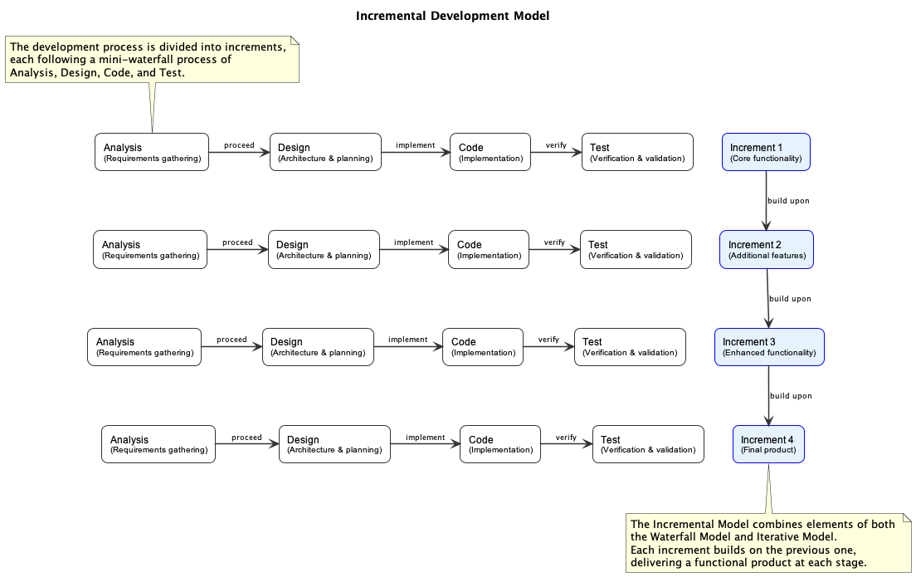

Figure 1. Incremental Model Diagram

1. Requirements analysis and planning:

First of all, the system requirements analysis was carried out to figure out the main functional modules of the project, which for me, the driving school, is that, the class reservation, by communicate with students who are currently practicing in driving school, we have confirmed the user requirements.

1. Database design and develop:

At this point, the design of the database, including the structure and data had been completed, use MySQL database for data storage, and use Navicat to organize and manage the database, based on the requirements from the project, the related database tables are designed, including the user table, role table, permission table, order table, etc., and manage the data interaction by using MyBatis Plus.

1. Front-end development:

Then, for front-end, Vue.js 2.x framework is used for develop, Vue Router is used for front-end routing management, Vuex is used for state management, to make sure the data consistency and sharing across components. The Element UI provides a huge number of ready-made components as a library of UI components, making the page design more efficient, HTTP requests via Axios for data interaction with the back end, the functions for the front-end are including user login, data display and form submission, etc.

1. Back-end development:

And then, the back-end is built by using the Spring Boot 2.2.2 framework, use the MyBatis Plus for ORM operations to make the CURD operation easier and simpler. Apache Shiro is used for implementing permission management, to make sure that different user have different operation authority in different system. Using FastJSON to perform highly efficient JSON data process, make sure a smooth transmission from front-end to back-end, the functions for the back-end are including user registration, login verification, data processing and rights verification and etc.

1. Integration and testing:

At last, for the last stage, the front-end and back-end code are integrated, and performed a series of functional tests and performance tests, make sure the stability and efficiency of the system. During the test procedure, GitHub had been used for version control, in order to make sure that each function module’s independence and reliability, using ECharts to display the data on the admin terminal to enhance the visualization function of the system.

So, each incremental stage will be reviewed and improved to make sure that the function of the system can be better step by step, and finally reach the final version.

## **Technology**

Technology (Software) which used during this website develop.

|  |  |  |  |  |  |
| --- | --- | --- | --- | --- | --- |
| Framework | Language | IDE | Front-end development | Back-end development | Database |
| Vue.js 2.x | JavaScript | IntelliJ IDEA | Vue.js, Element UI, Vue Router, Vuex | Spring Boot 2.2.2, MyBatis Plus | MySQL |
| ECharts | JavaScript | IntelliJ IDEA | ECharts | Apache Shiro |  |
| Quill Editor | JavaScript | IntelliJ IDEA | Quill Editor | Lombok, FastJSON |  |
| Axios | JavaScript | IntelliJ IDEA | Axios |  |  |

Table 3. Software used for developing website

Technology (Hardware) which used during this website develop.

|  |  |  |
| --- | --- | --- |
|  | Classification | Environment |
| Hardware | CPU | 11th Gen Intel Core i7-11800H @ 2.30GHz 8Core 16Threads |
| GPU | NVIDIA GeForce RTX 3070 Laptop GPU 8GB(VRAM) |
| CUDA Version | 12.1 |
| CuDNN Version | - |

Table 4. Hardware used for developing website

* + 1. Front-end technology

1. Vue.js 2.x

* Core structure: To realize and implement dynamic pages and interactive user interfaces, with flexible componentized structure that makes development more modular and maintainable.
* Application:
* Modular development, improve code reuse rate and maintainability.
* Two-way data bond, realize real-time verification and submission of form data.
* Life-cycle management, manage component loading, updating, and destruction processes properly.
* Efficient page rendering, improve users’ using experience.

1. Element UI

* UI component library: Provide a large variety of web components, can form a common website page quickly, improving the efficiency of website developing.
* Application:
* Table component: Using it for display student information, test records, etc., support paging and sorting.
* Form component: Using it for student registration, information modification, and form verification.
* Popup module: Using it for operation feedback and confirmation.
* Navigation component: Using it for realize the menu navigation.
* Date selector: Provide a flexible interface of choosing date.

1. Axios

* HTTP request tool: Using for front-end and back-end data interaction.
* Application:
* Request interceptor: All the data will be added a request header, in order to simplify the authentication process.
* Respond interceptor: Unified the way that handling of errors, data format conversion, etc.
* Interface management: All the API requests will be managed in a unified manner, so it’s easier for maintenance.
* Concurrent request: Improve data loading efficiency.

1. Vue Router

* Route management tool: Realize the navigation between pages and views.
* Application:
* Route configuration: Distribute route by different system module.
* Route guard: Realize the access control.
* Lazy loading: Reduce the time from the first screen loading.
* Route parameter passing: Using the URL to transmit the data.

1. Vuex

* State management tool: Manage global state to make sure the sharing and consistency of the data.
* Application:
* User information: Store the identity and clearance of the user, who is currently logged in.
* System configuration: Manage global configurations of the system, like the theme setting.
* Cache data: Store the data which uses the most, reduce repeat request.
* State persistence: To store state by using localStorage.

1. Quill Editor

* Rich text editor: Support multiple formats of test editing.
* Application:
* Notification bulletin editing: Admins can write the system notification.
* Course description: Can modify the detail of the course, support rich media content.
* Feedback processing: Support rich text format responses.
  + 1. Back-end technology

1. Spring Boot 2.2.2

* Back-end framework: Simplify the configuration and development of JAVA application, can build up service in a very short time.
* Application:
* Automatic configuration: Reduce the XML configurations, improve efficiency of develop.
* Dependency management: Simplify the management process by using the starter dependency.
* RESTful API: Standardized back-end data interaction.
* Unified exception handling: Global exception handling via @ControllerAdvice.
* Scheduled tasks: Use the @Scheduled annotation to implement scheduled tasks.

1. MyBatis Plus

* ORM framework: To simplify the use of MyBatis, generate CRUD operation automatically.
* Application:
* General CRUD: Automatically realize the operation of adding, deleting, modifying and checking, in order to reduce the writing of SQL.
* Condition constructor: Construct complex query condition.
* Paging query: Simplify the logic of paging query, in order o improve readability.
* Logical deletion: Prevent the physical deletion damage to data.
* Auto fill: Automatically fill the creation time, update time and other fields.

1. Apache Shiro

* Secure framework: Realize user authentication and permission management.
* Application:
* Identity verification: User login authentication, supporting multi-role login.
* Clearance control: Role-base access control.
* Session management: Session timeout control and concurrent login restriction.
* Remember me: Improve user login experience.
* Security interceptor: Implements URL access control.

1. Lombok

* Simplified developing tool: Reduce the boilerplate code in Java entity classes
* Application:
* @Data: Generate setter, getter, equals, hashCode and toString method automatically.
* @Builder: Provides a builder pattern to simplify object creation.
* @Slf4j: Simplify the creation of log object.
* @AllArgsConstructor, @NoArgsConstructor: Generate constructor automatically.

1. FastJSON

* JSON process tools: Used to serialize and deserialize data.
* Application:
* Object serialization: Converts Java objects to JSON strings.
* Data parsing: Convert JSON data from the front-end into Java object.
* Data filtering: Protects sensitive fields.
* Date formatting: Ensure that the date format on the front and back ends is the same.
  + 1. Database technology

MySQL

* Database system: Use it for data storage and management.
* Application:
* Table structure design: Design tables including users, roles, students, coaches, courses and etc.
* Index optimizing: Improve query efficiency, building index.
* Foreign key association: Maintains relationships between tables to ensure data consistency.
* Transaction management: Ensures atomicity of data operations.
* Data backup: Periodically back up data to ensure data security.
  + 1. Development environment and tools

Maven

* Build tools: Simplify the dependency management and project build process.
* Application:
* Dependency management: Use pom.xml to centrally manage project dependencies.
* Project build: Using Maven orders to compile and package the project.
* Plug-in extension: Support resource processing, code inspection and other functions.

## **Project Version Management**

This project used Git as the version management tool, to manage the project version through GitHub. GitHub repository will contain project files, versions, update information and upload time, if there wasn’t any new function been updated, then the version number will stay the same.

The details will be shown in the figures down below:

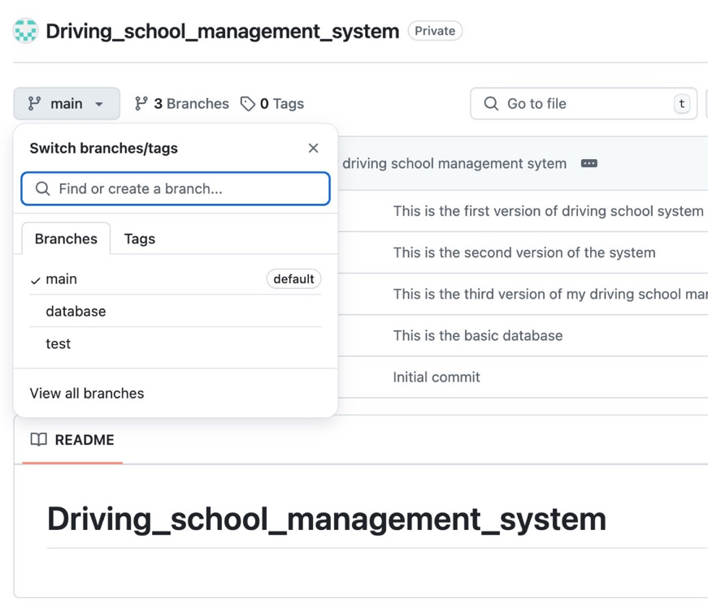

Figure 2. Branches for project

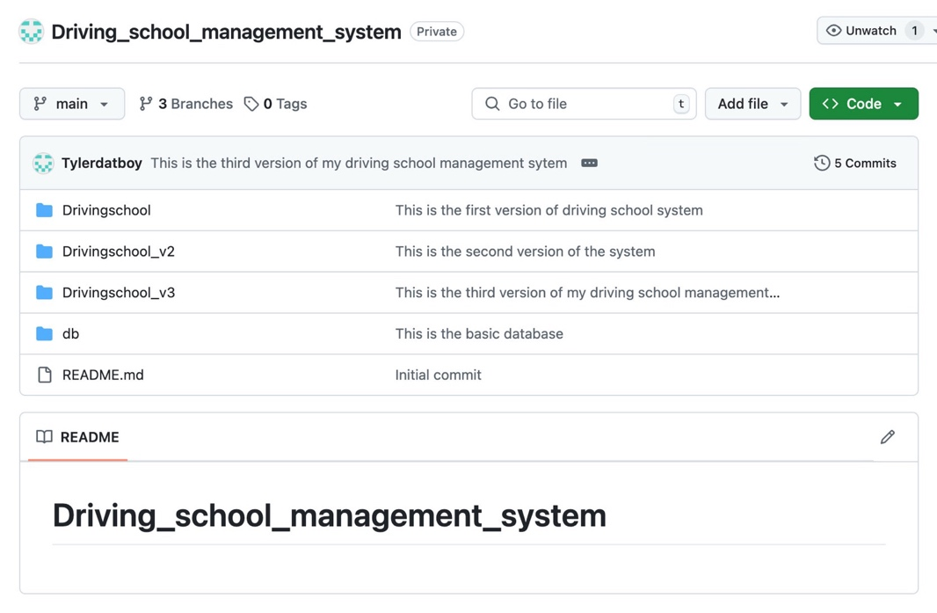

Figure 3. Main branch

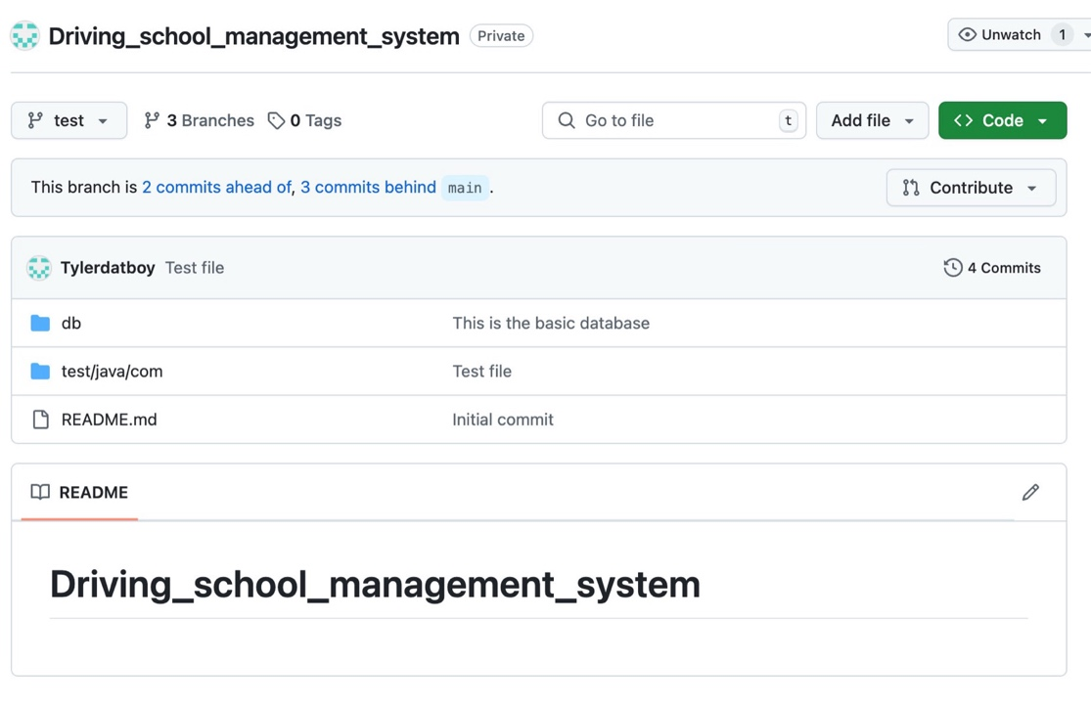

Figure 4. Test branch

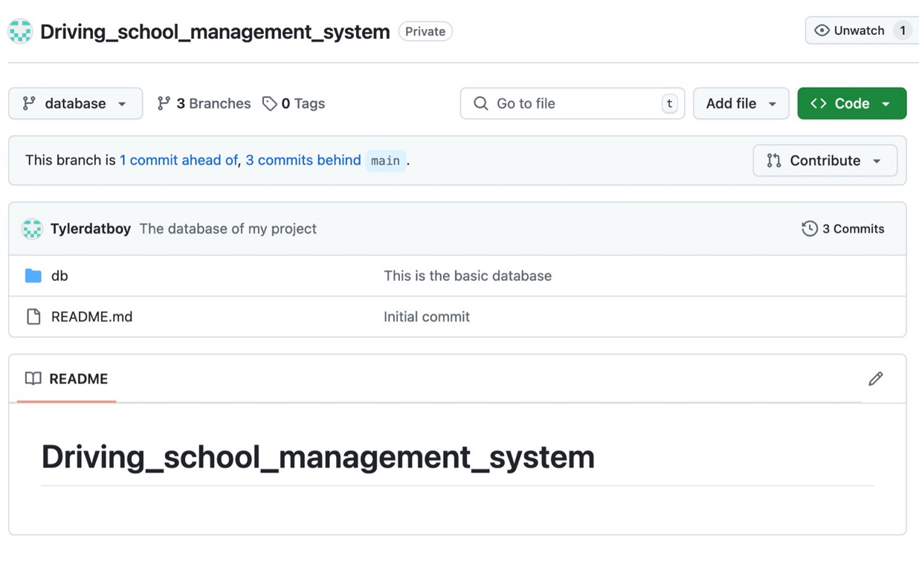

Figure 5. Database branch

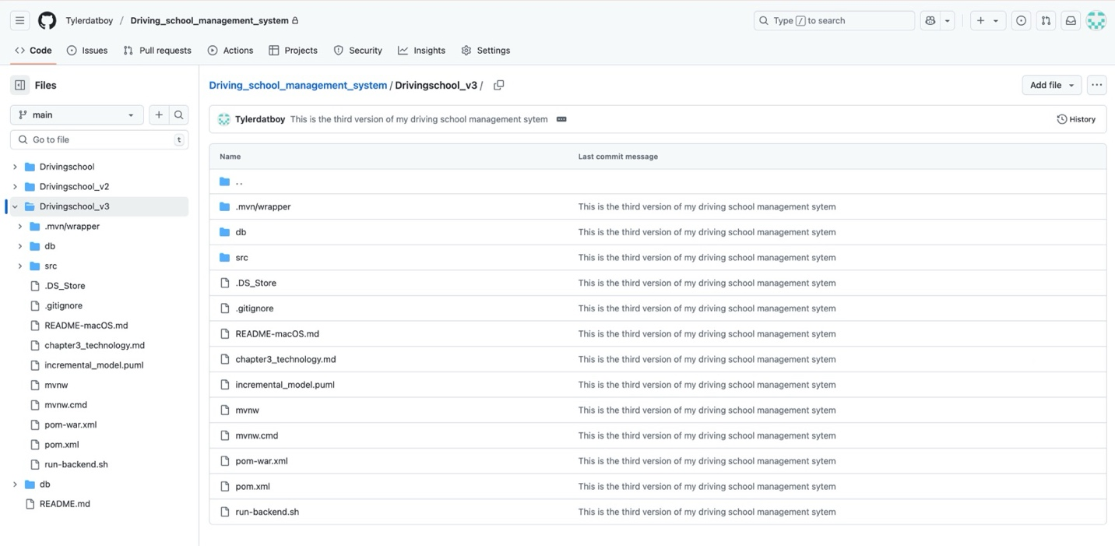

Figure 6. The final version Drivingschool_v3

Project been developed in incremental model, so the version will versions continue to update, and after each update will be a new version. Each update will involve new codes and data, all of them will be stored in a new folder, so it’s convenient for management and development later on. Manage all the version by Git, can effectively simplify the development process.

# **Implementation and Results**

This section is to show the logic of my project design and to display currently results of my project, and also with testing, then have a feedback base on the results, and make reasonable evaluation of the process.

## **Design**

**User interface functions design**

Base on the concept of this management system, this system has 3 roles, which are Administrator, Student and Coach, all the functions are realized by real-time data transmission and interaction. So, here’s a diagram to display the overall function of this system, as well as the use case diagram, all the diagram will be shown below:

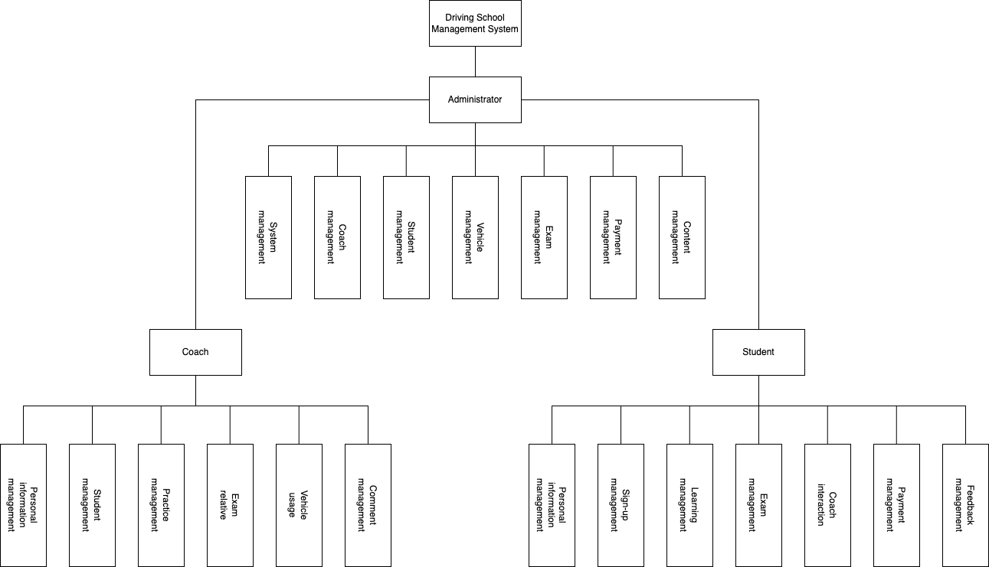

Figure 7. Functions diagram

This system includes multiple role modules: Administrator, Coach and Student. Base on the requirement analyze, the system design accomplished a full function structure, including user management, coach management, student management and practice management and other core functions, each different function modules can realize collaboration between different roles through data interaction and logic.

And the following diagrams are the use case diagrams for Administrator, Coach and Student:

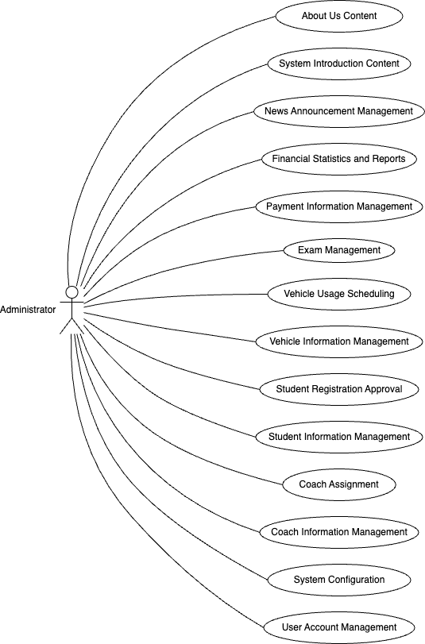

Figure 8. Use case diagram for administrator

Administrator:

* Responsibility: In charge of global management of the whole system, including coaches, students, vehicles and etc.
* Core Functions: Account management, content creation, payment creation, system configuration and etc. Administrator has the full clearance for system maintenance, data management and etc.

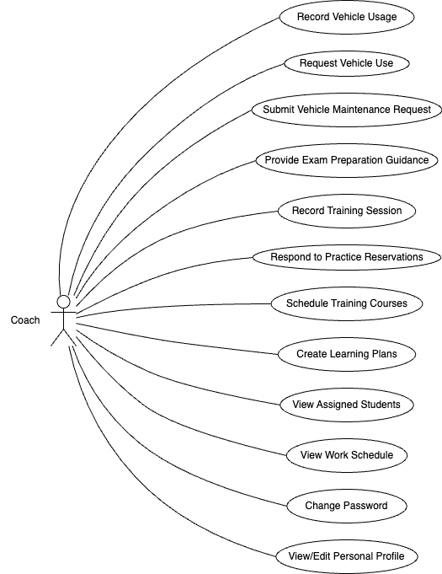

Figure 9. Use case diagram for Coach

Coach:

* Responsibility: Mainly have to interact with students, doing session arrangement and practice management.
* Core functions: Log and manage practice session, arrange learning plan and etc. Coach often has a closer relationship with student, so they might focus more on student’s learning progress and practice progress.

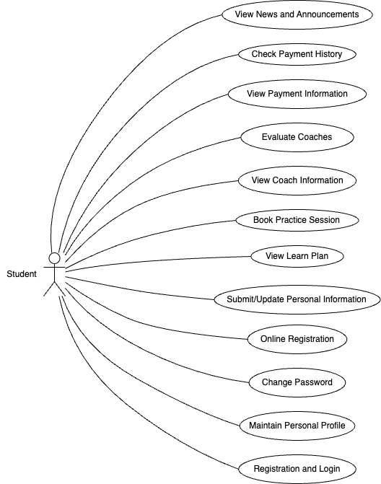

Figure 10. Use case diagram for Student

Student:

* Responsibility: Students can manage themselves through this system, can make reservation by checking the timetable, and can also access their personal plan and arrangement.
* Core Functions: Check news and notification, manage personal profile, book practice time and etc. The system provides many self-service functions, students can easily manage their progress.

**Database Design**

The database including core tables like User table, Student table, Vehicle table, Reservation table and etc. All the tables will be shown at the ER diagram below, make sure the integrity and consistency, database acquired MySQL, Navicat, migrating MyBatis Plus to realize high efficiency data access.

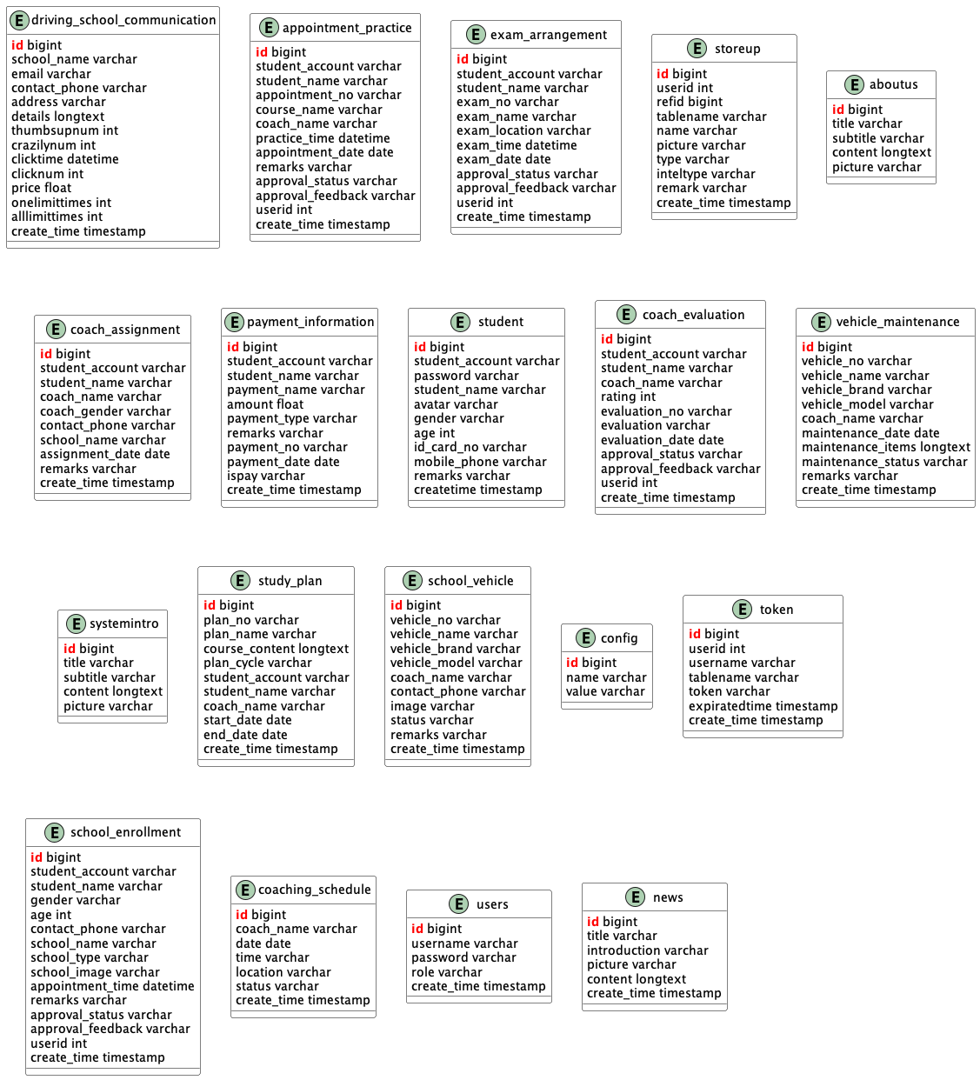

Figure 11. ER diagram for database

**Database analyze of driving school management system**

**Core tables:**

1. student

Store the basic information for the students, including student’s account, password, name, avatar, gender, age, ID number, phone number and etc. As one of the core users of this system, the student data is the foundation of the management system.

1. school enrollment

Documented the information when student sign up for driving school, including student’s account, name, gender, age, phone number, name of the driving school, reservation time, status and etc. This is the starting point of a student at driving school, can show the process of a student build up a relationship with a driving school.

1. coach assignment

In charge of the distribution relationship between students and coaches, documented the students’ accounts, names, the coaches’ names and phone numbers and etc. The important point is, that this table can support the coach distributing system, which is vital part during the student training process.

1. study plan

Store the study plan for each student, including index, name, course content, period, student information, coach name, start/end time. This table shows the systematic of the system.

1. appointment practice

Record the information of practice reservation which the student made, including student name, account, reservation number, session name, coach name, practice time and etc. This table is the core table of realizing student can make online reservation.

1. exam arrangement

Manage information that related to the exam, including student account, name, exam number, exam location, time and etc. It shows that this table support the driving school test management process, to make sure that the exam will be held orderly.

1. school vehicle

Store the vehicle information, including the vehicle number, brand, model, coach who is responsible for, contact number, status and etc. Vehicle as the most important property of driving school, need to be look after well by using this table.

1. vehicle maintenance

Documented the vehicle maintenance records, including vehicle number, name, brand, model, maintain date, maintain items and etc. Make sure vehicle can operate normally.

**User interaction table**

1. coach evaluation

Store the feedback of coaches that given by the students, including student number, name, coach name, rating, comment content, comment date and etc. This table support teaching quality feedback system, ca be helpful of improving teaching quality.

1. payment information

Manage the student’s payment records, including student number, name, payment name, payment amount, payment number, payment date and etc. This shows that the system supports financial management system.

1. storeup

Recording user’s collection data, including user ID, index ID, table name, name, images and etc. This table is aiming to improve the user experience, allows users to save content which they like.

1. coaching schedule

Manage the work plan of the coach, including coach name, data, duration, location and time. This table support the work management of the coach, realized the resources balance and distribution.

**System management table**

1. users

Stores all the accounts of all the users, including username, password, roles and etc. As the fundamental table for the system, to manage all the users’ verification information.

1. token

Manage the user login token, including user ID, username, table name, token content and expire date. This table support the security authentication mechanism of the system.

1. config

Stores the config of the system, including config name and value, which is used for global configuration management.

**Content management table**

1. news

Stores the news announcement data, including title, introduction, images and content. This table support the news function of the system.

1. aboutus

Manage “aboutus” content page, including title, second title, content and images. This table is used to display the introduction of the driving school.

1. systemintro

Stores the introduction of the system, including title, second title, content and images, this table uses to show the system’s function introduction.

1. driving school communication

This table stores different driving school’s contact information, including driving school name, email, contact number, address and etc. This basic communication information of the driving school, support the communication function of the system.

These table construct the data foundation of the driving school management system, can offer support to student from sign up, coach distributing, make practice plan, make practice reservation to take exam, which complete a full training cycle for students, meanwhile manage the vehicle resources, payment information and etc. make sure to performing an effective system.

## **Implementation**

**Student, Coach interfaces and interaction**

After browsing a few driving school management system websites, a homepage of my own project was designed and optimized, the homepage will be shown below:

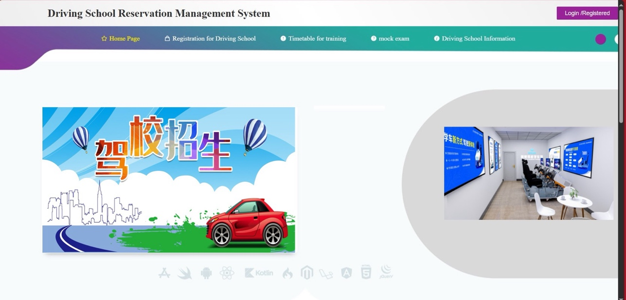

Figure 12. Homepage

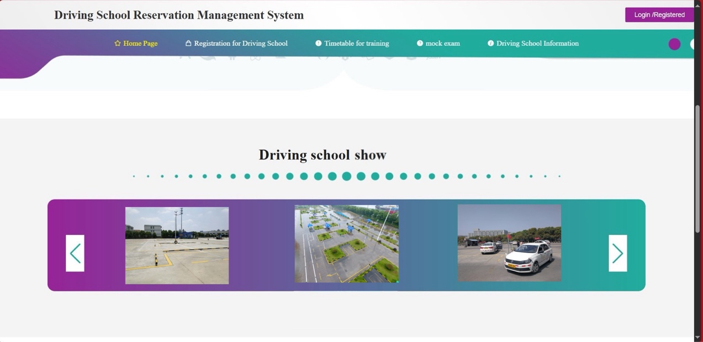

Figure 13. Homepage

The homepage is clean and straight-forward (state of not logged in), it’s convenient for users to access functions quickly. At the top of it, there’s navigation bar, with “Home page”, “Registration” and etc. buttons, user can visit different pages and find what they want more easily. And the pictures in the middle can show the facilities and teaching environment of the driving school.

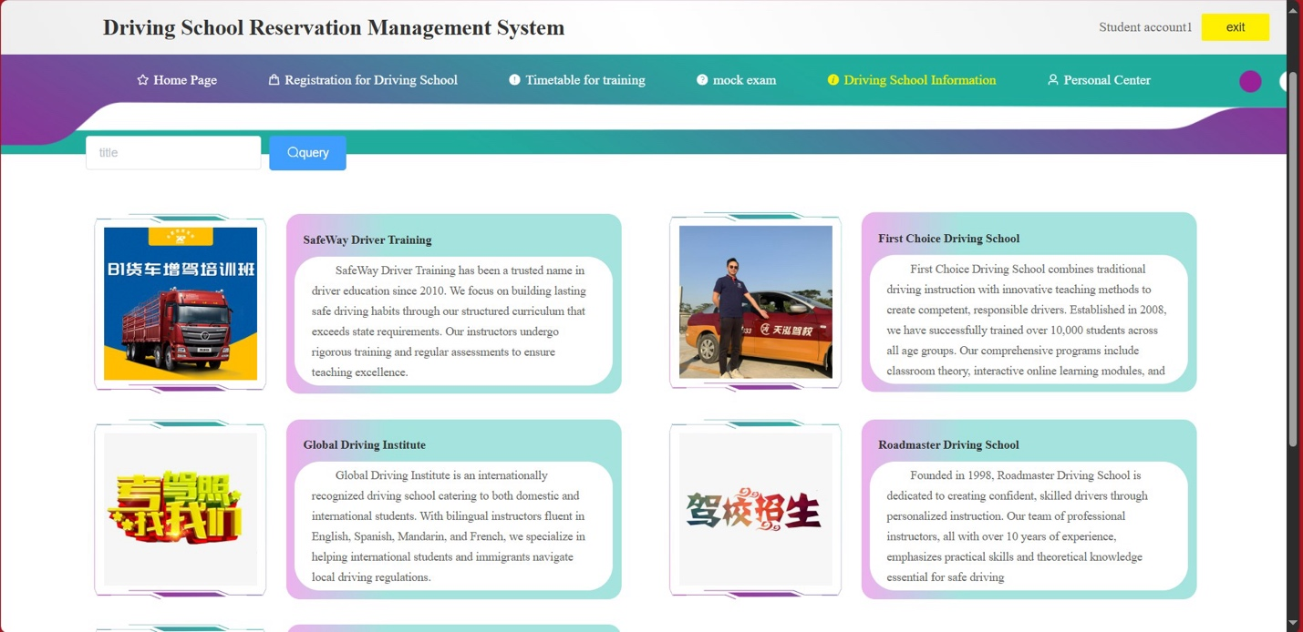

Figure 14. Driving school information query page

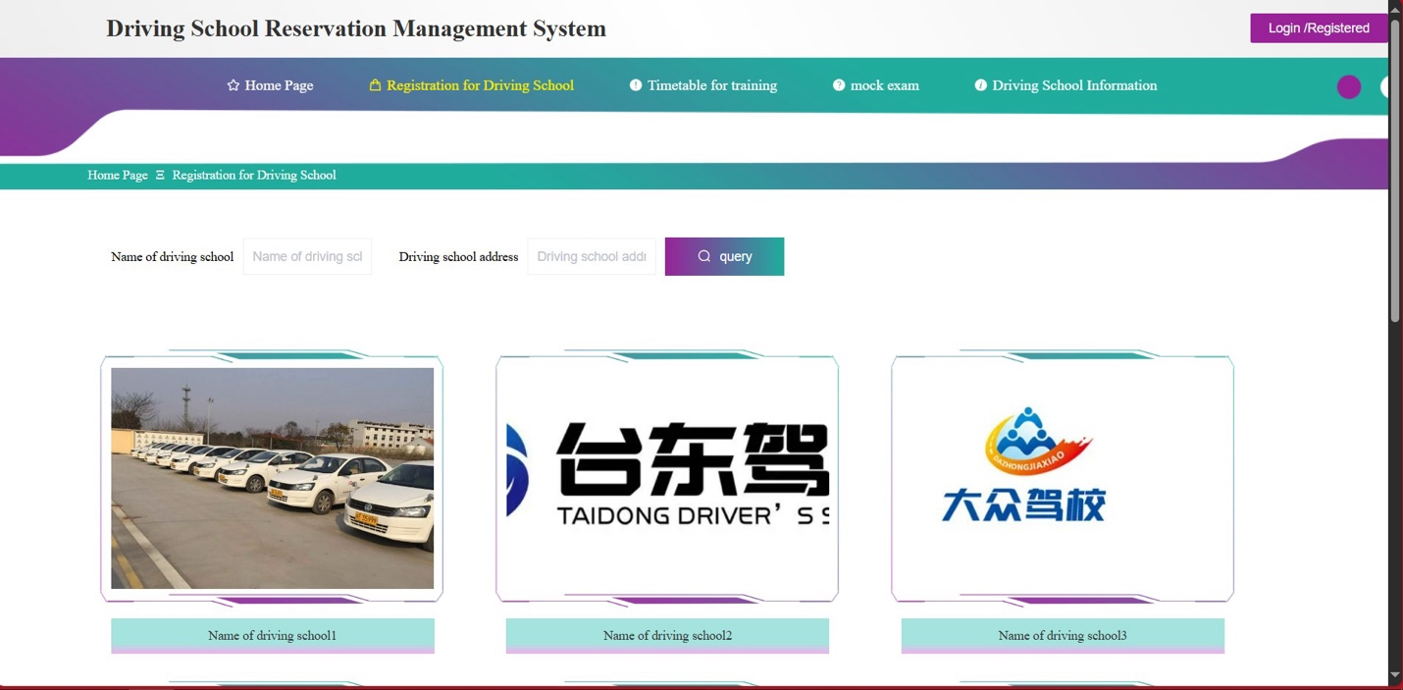

Figure 15. Driving school information query page

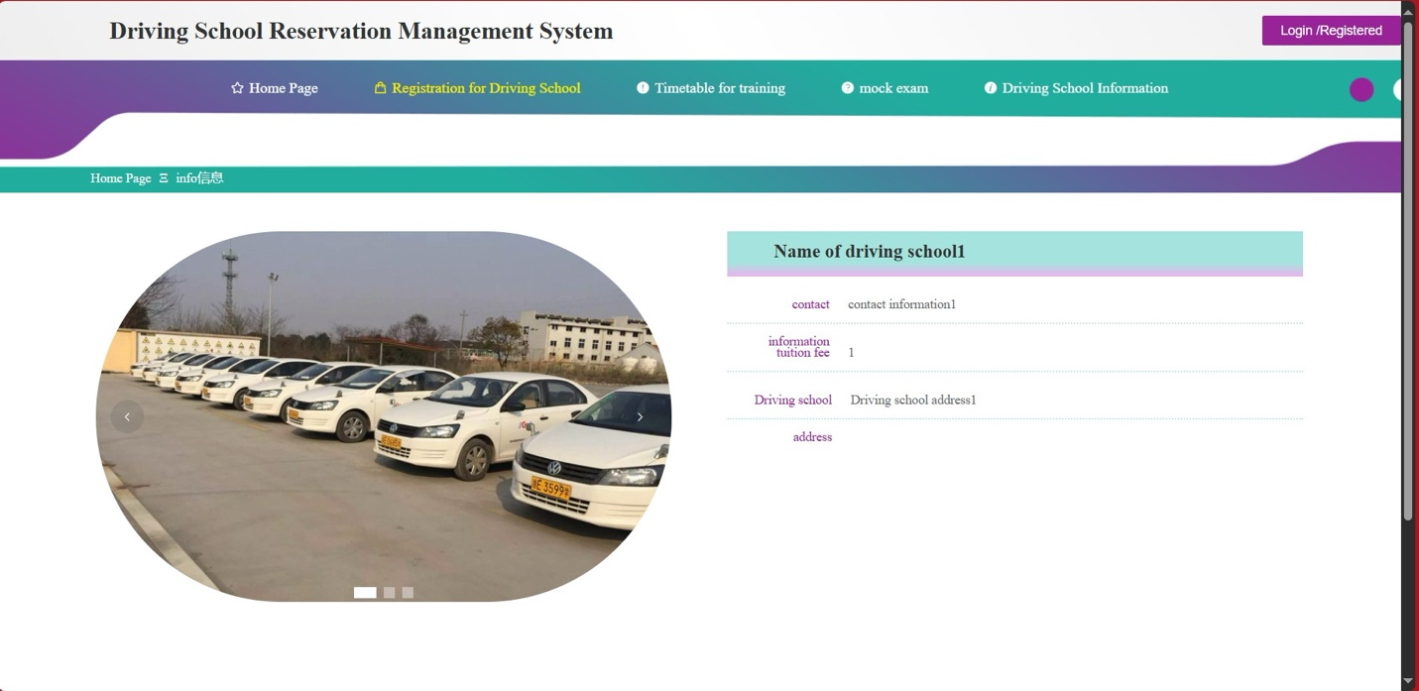

Figure 16. Driving school information

This “Driving school information query system” provided a clean interface, users can search by typing key words, and then click “Query” button to search, at the content below, cards are showing information about all the driving schools, each card includes school name, introduction and images, help the user have a better understanding of each school’s features and services. Whole page is clear designed, suitable for user to browsing to find school.

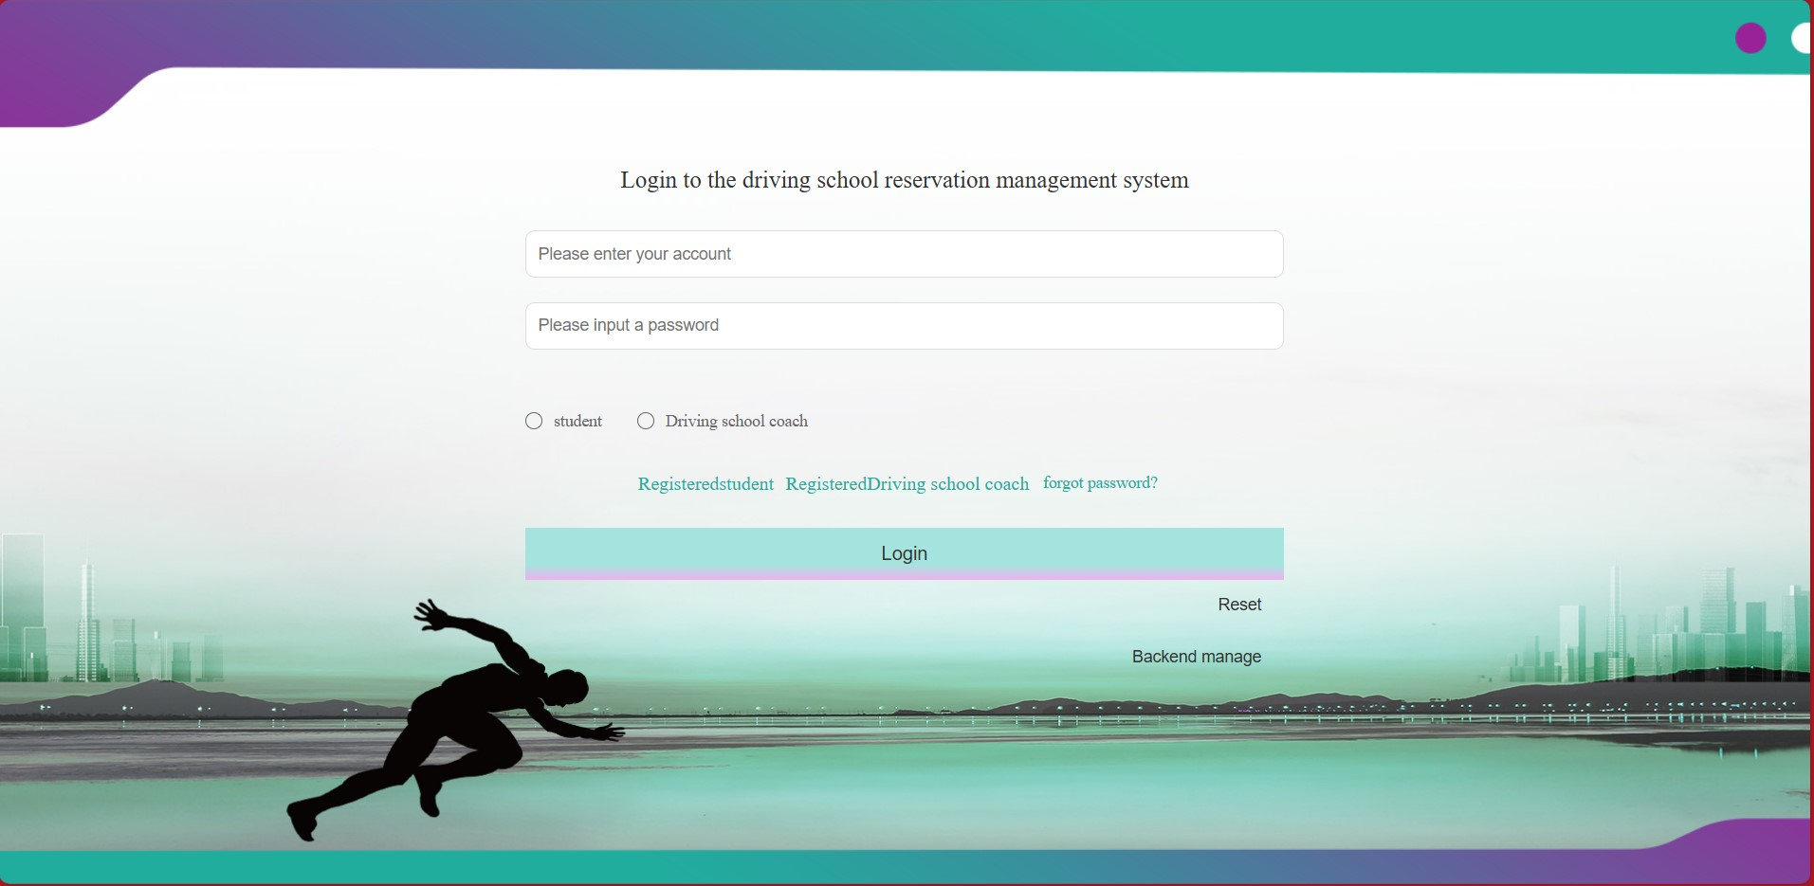

Figure 17. Front-end login page

This login page uses modern and clean design language, the background shows the city and sports vibe, can improve visual appeal. User can input account and password, can also choose roles, the input boxes is clear, and also have role selection radio buttons, login and reset buttons, and provides registration, forgotten password, and background management link, making sure it’s easy and straight-forward to use.

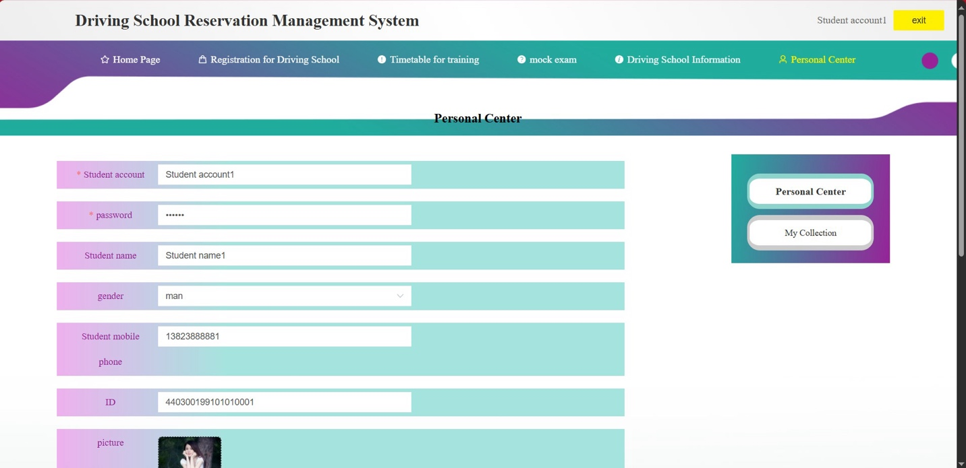

Figure 18. Personal center

Login as student, can enter the personal center of the student, student can modify their personal information, including student number, password, name, gender, phone number and etc. The page also provides image upload module, user can upload images through it, whole design is aiming to help user to manage their personal information easily.

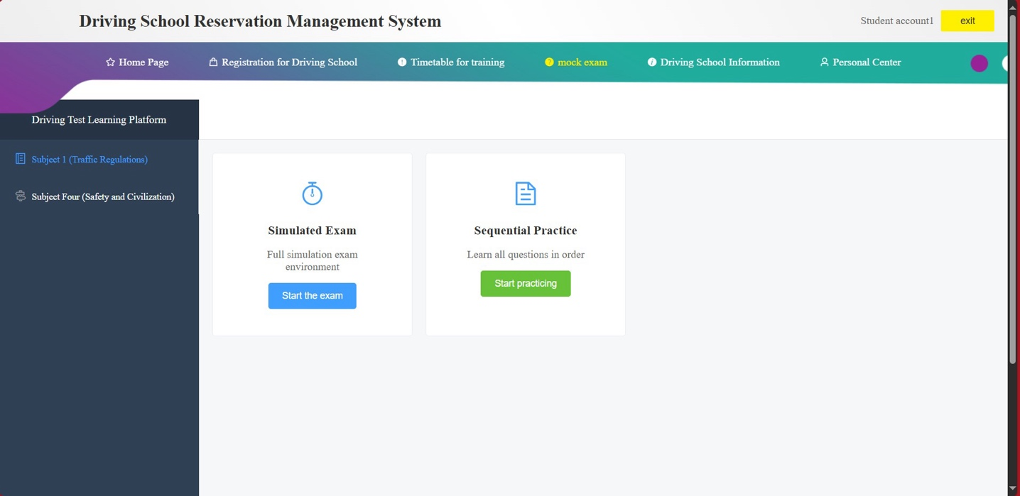

Figure 19. Mock exam interface

This page is the mock exam simulation page, user can choose different subjects to learn and do exams, like exams from subject 1 and 4. This page provides to main function buttons, the first one is the “Simulation Exam”, to provide user a full experience of the real exam. The second one it called “Sequential Practice”, this one can help users to learn all the questions, user can use these modules to improve the pass rate of their exams.

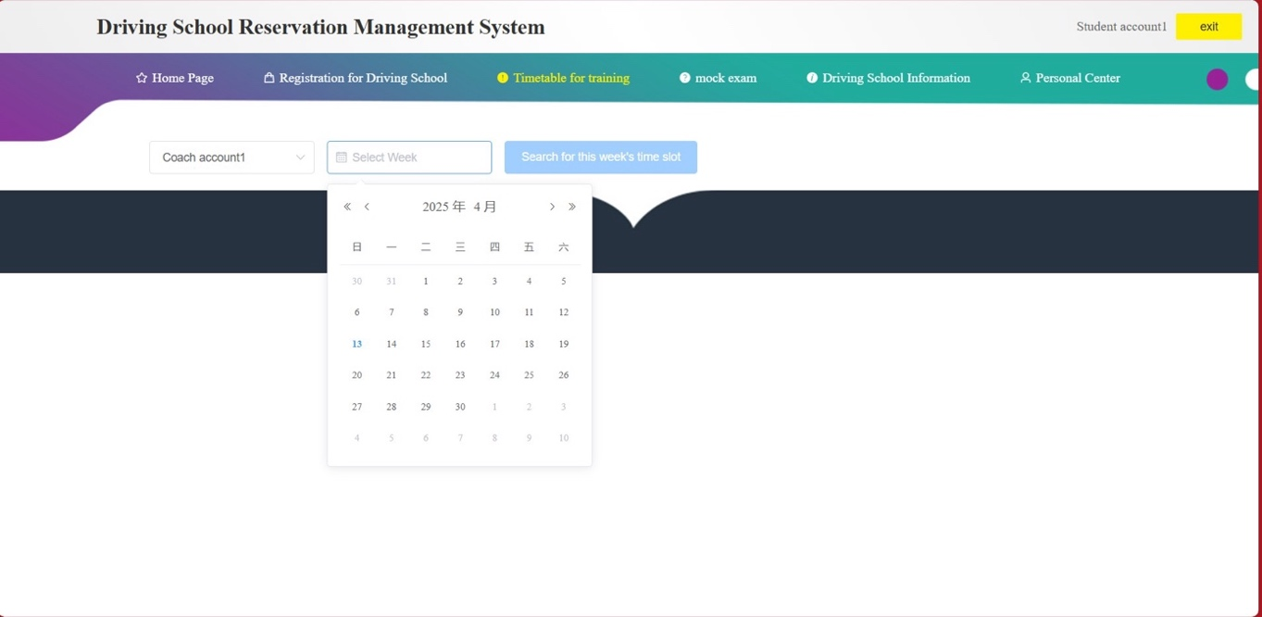

Figure 20. Student choose practice date

This page shows when student entering the “Timetable” of practice, then user need to pick a date to practice, but also to show a complete time table as shown below:

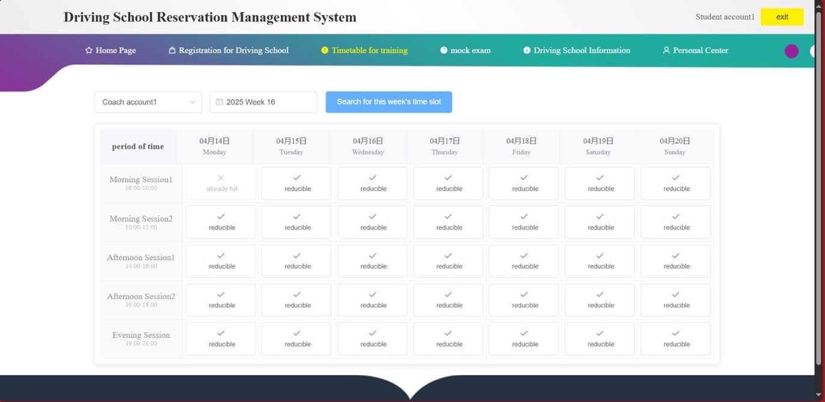

Figure 21. Timetable for student

This is the complete timetable of practice, student can click the check box which on the timetable, the one with “reducible” means user can chose, the one with “already full” means that it’s been reserved that day, so this can really help user to make practice reservation.

**Administrator**

The administrator is the role who has the highest clearance in the whole system, thus admin can manage all the content and data in the system, including core functions like user management, coach management, student management, vehicle management and etc. And admin can also control every aspect of the system, like create/delete account, coach distribute, exam arrangement and etc. and admin can do all these through the back-end manage platform, to manage the daily events of the system, make sure school business running smoothly, so the administrator have a different interface of homepage from normal student or coach.

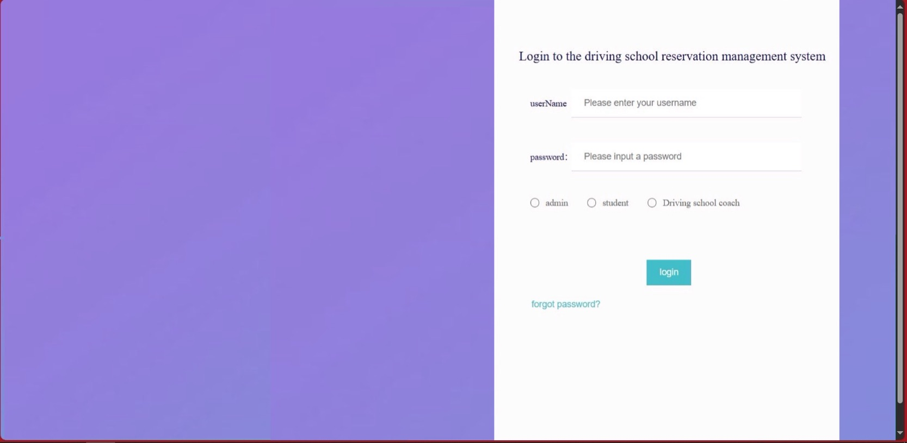

Figure 22. Back-end login page

This page shows the login page of back-end, administrator also need to input account and password, page includes clear input boxes and login button, meanwhile, there still provide “forgot password” link for user to reset their password. Design is clean, suitable for quick login.

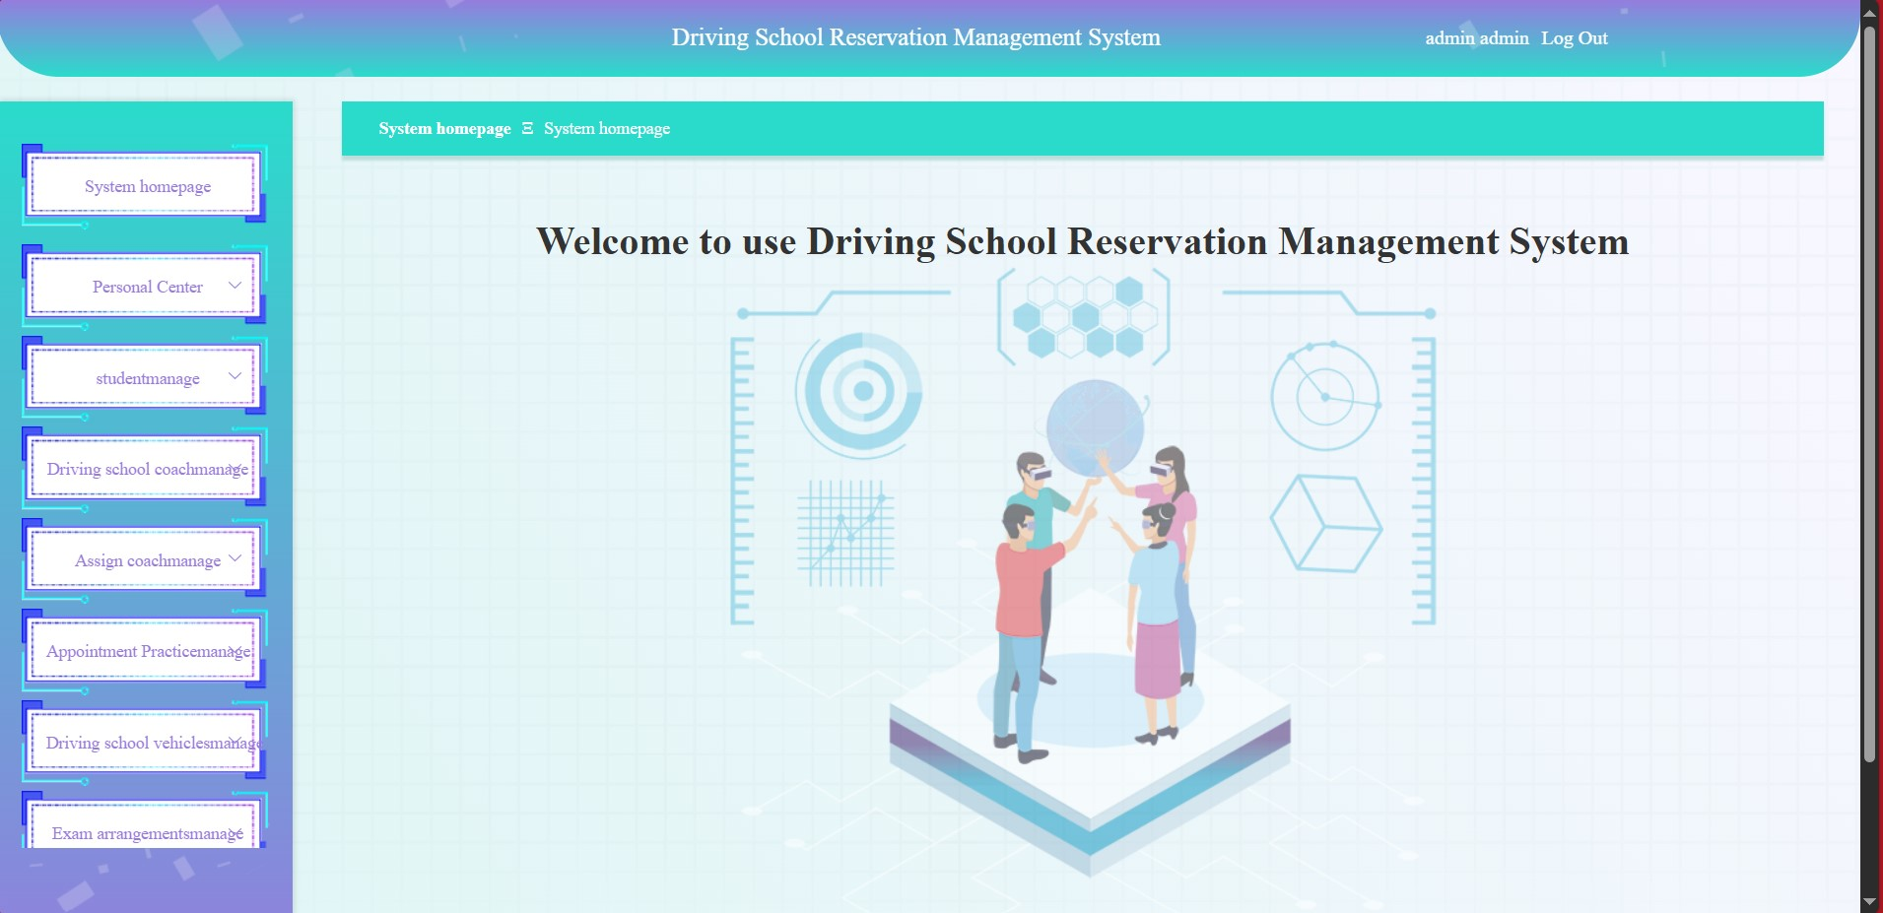

Figure 23. Administrator back-end page

After administrator login to the system, this page will show up, provide a clear navigation bar to organized all the function modules well, admin can use this page to check and manage or even monitor the system data, to make sure the system operates smoothly.



Figure 24. Dashboard

This image shows the side-navigation bars on the dashboard, provides multiple function management modules, the admin can access pages like system homepage, personal center, student management, coach management and etc. through the dashboard, each module has a expandable menu, make it easier for admin to operate and manage, whole design is clean and straight-forward.

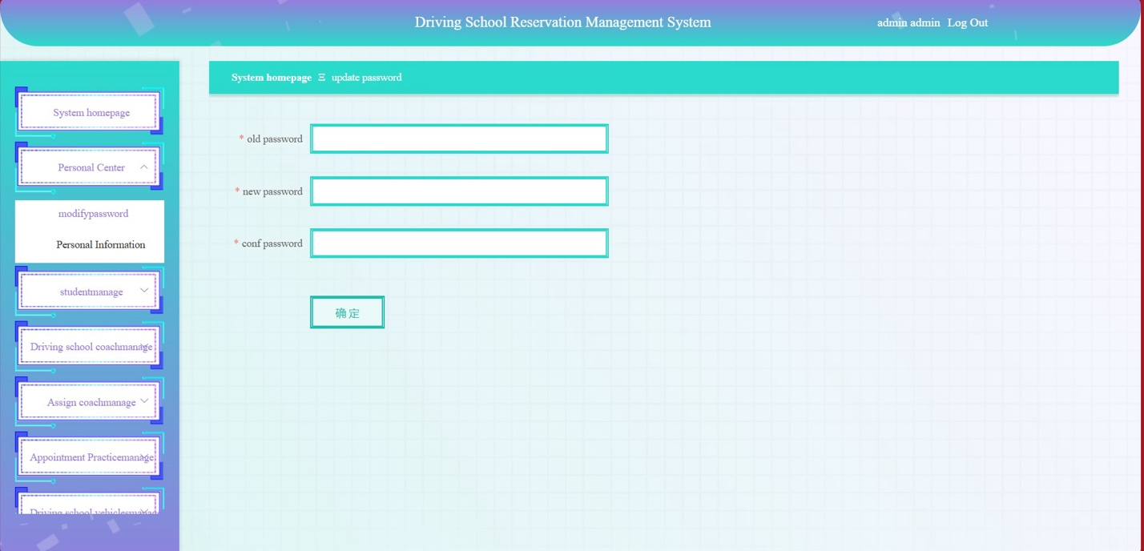

Figure 25. Administrator change password

This page shows the page that uses to change admin’s password, user can input new password and then check the new password by type the password again, but require input the old password to make sure that the administrator is indeed changing the password.

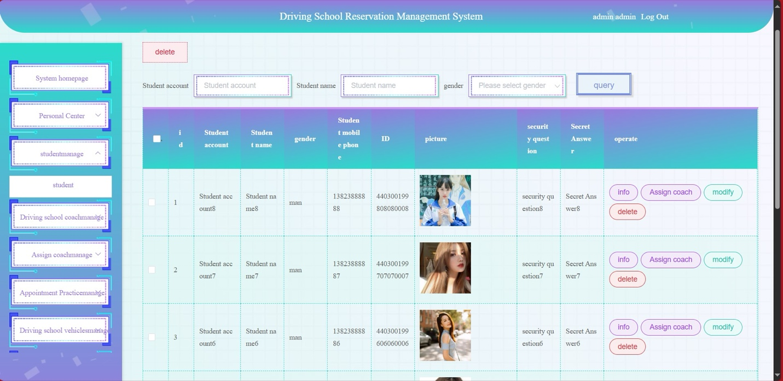

Figure 26. Administrator manage students

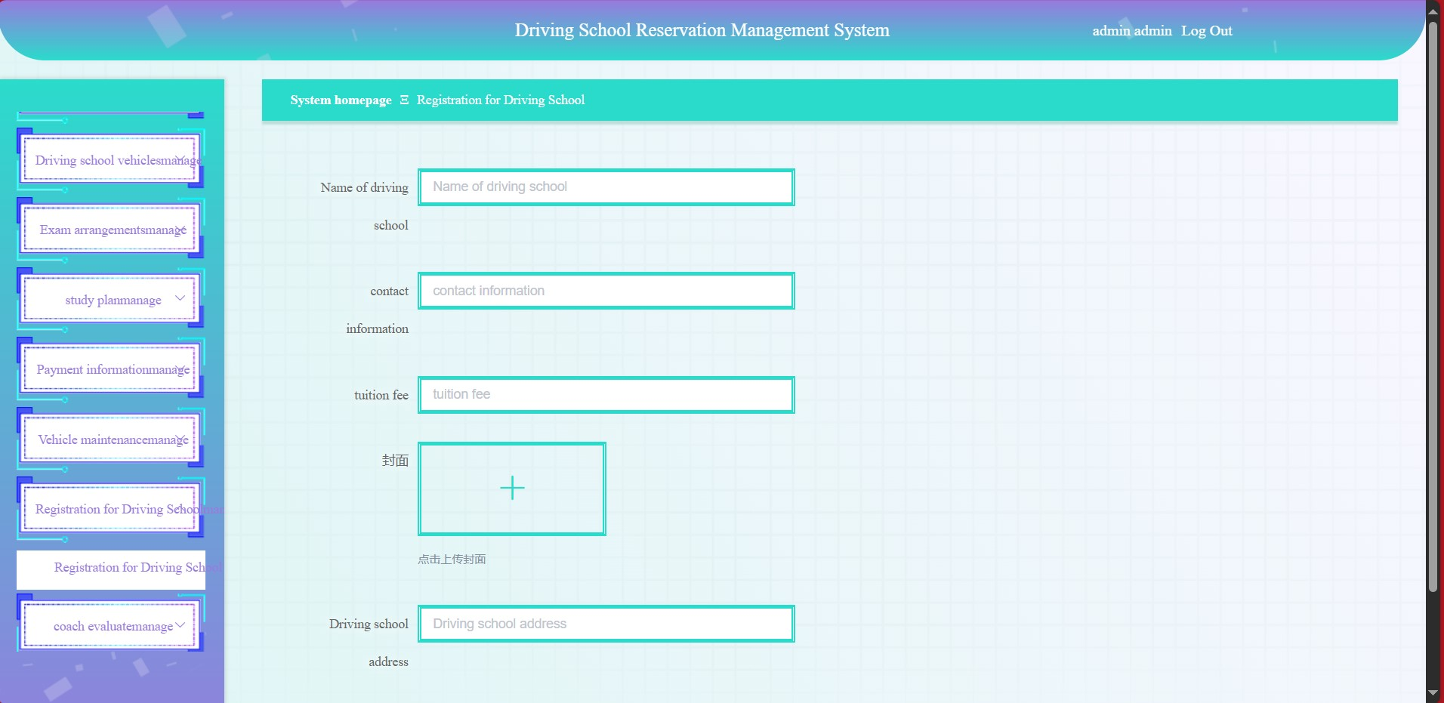

Figure 27. Administrator add student

These pages display the pages of admin manage all the student through the back-end manage platform, admin can look through student’s detail, including account, name, gender, contact number and etc. Admin can perform plenty of operations to the student information, like keep the information updated, make sure the accuracy of the information.

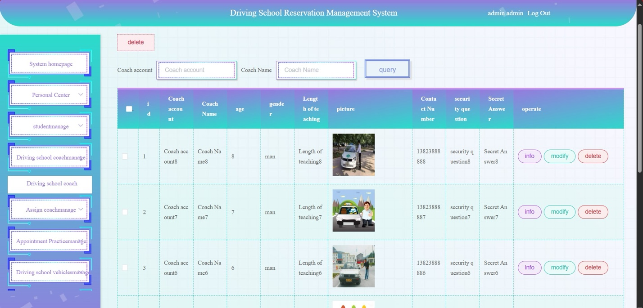

Figure 28. Administrator manage coaches



Figure 29. Administrator add coach

Thess pages show the detail information of the coaches, admin can check the information including account, name, age, gender, teaching age, contact number and etc. Each of the information is followed by a series of “info”, “modify” and “delete” button, admin can do these operations to the coaches’ information.

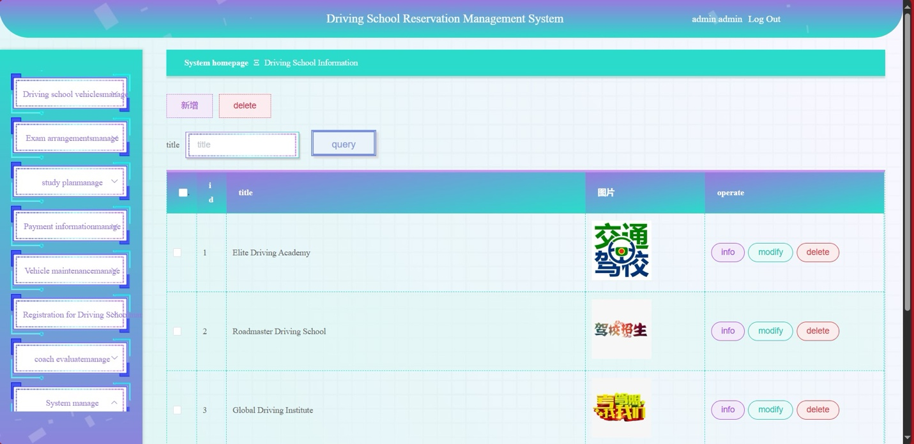

Figure 30. Administrator manage driving schools

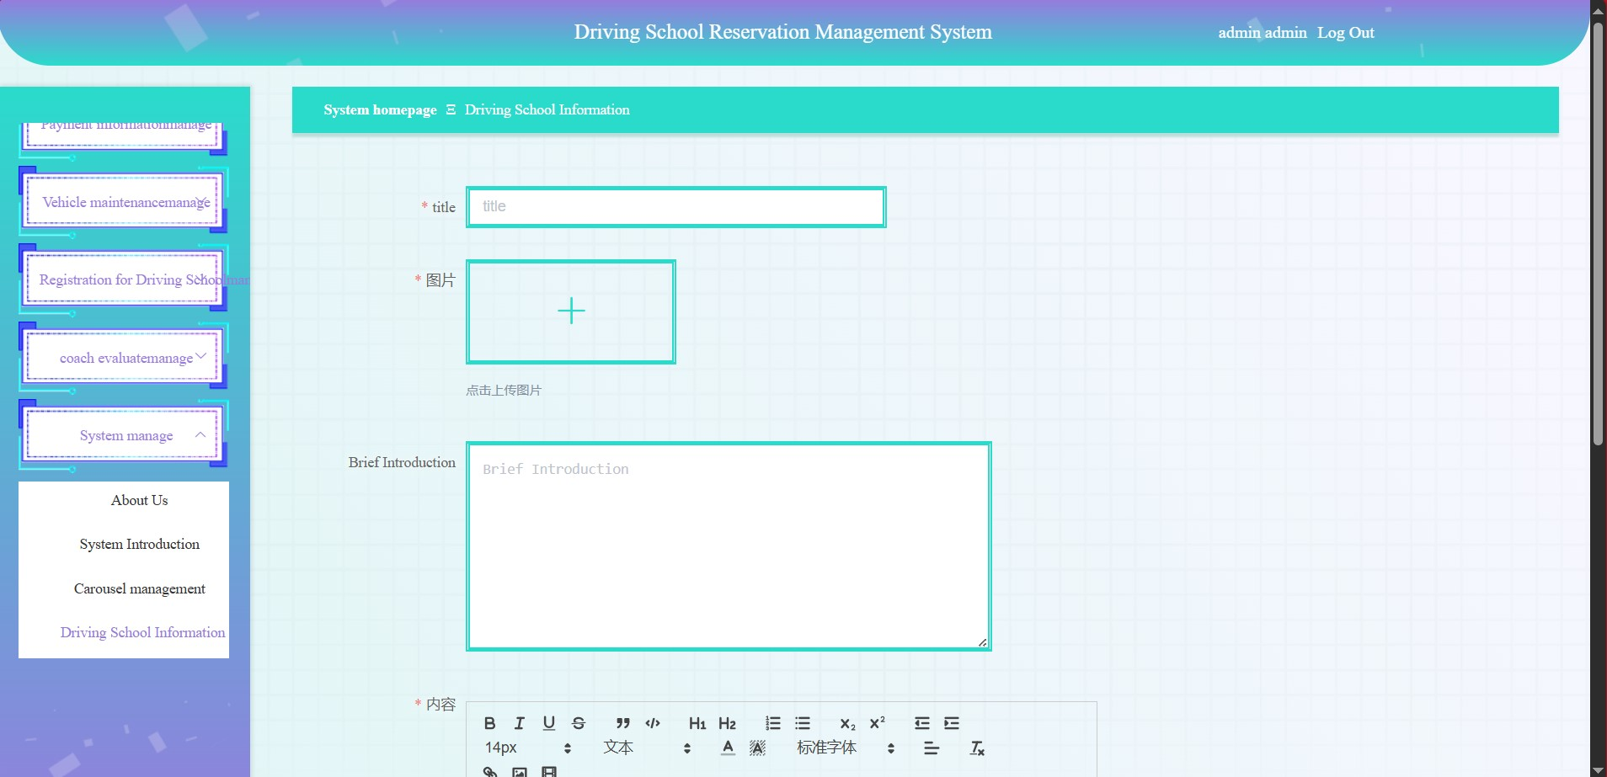

Figure 31. Administrator add driving school

These pages show the detail information of the driving schools, admin can check the information including name of the driving school, details, logos and etc. Each of the information is followed by a series of “info”, “modify” and “delete” button, admin can do these operations to the driving schools’ information.

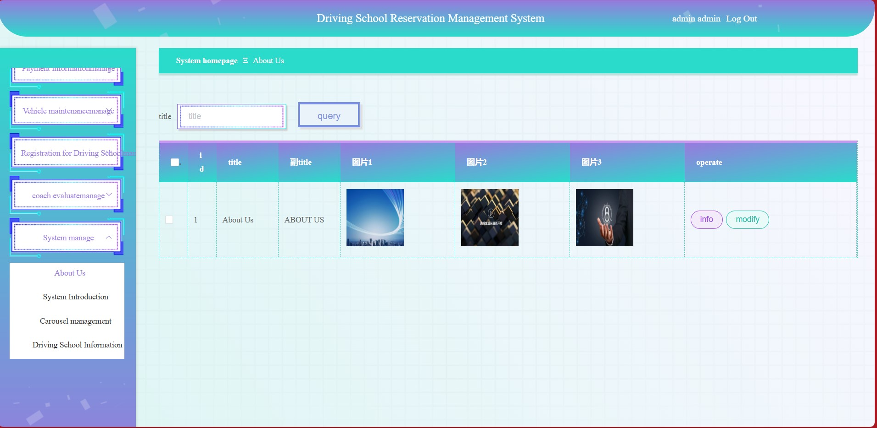

Figure 32. Administrator manage driving school "About us"



Figure 33. Administrator modify driving school "About us"

These pages show the detail information of the driving schools’ “About us”, admin can check the information including title, secondary title, image1 and 2 and etc. Each of the information is followed by a series of “info”, “modify” button, admin can do these operations to the driving schools’ “About us”.

The driving school management system's core features have all been fully implemented, and other features have been mostly included.

## **Testing**

1. **Unit Testing**

This test is to list multiple function tests, and test them one and another separately, to check if them can work perfectly. First, we need to list all the function, and then distribute different test case depend on different functions, and run them then record the test result, the logic test and its results are shown below:

|  |  |  |  |  |
| --- | --- | --- | --- | --- |
| Use case ID | Operation description | Test data | Expected result | Test state |
| 1 | Enter the account and password, select Student Identity, and click the login button. | Account: Student account 1  Password: 123456 | Login Succussed | Same with the expected result |
| 2 | Enter the account and password, select Student Identity, and click the login button. | Account: Student account 1  Password: admin | Login Failed | Same with the expected result |
| 3 | Enter the account and password, select Coach Identity, and click the login button. | Account: Student account 1  Password: 123456 | Login Failed | Same with the expected result |

Table 5. Unit test plan

The test process and result are shown below:

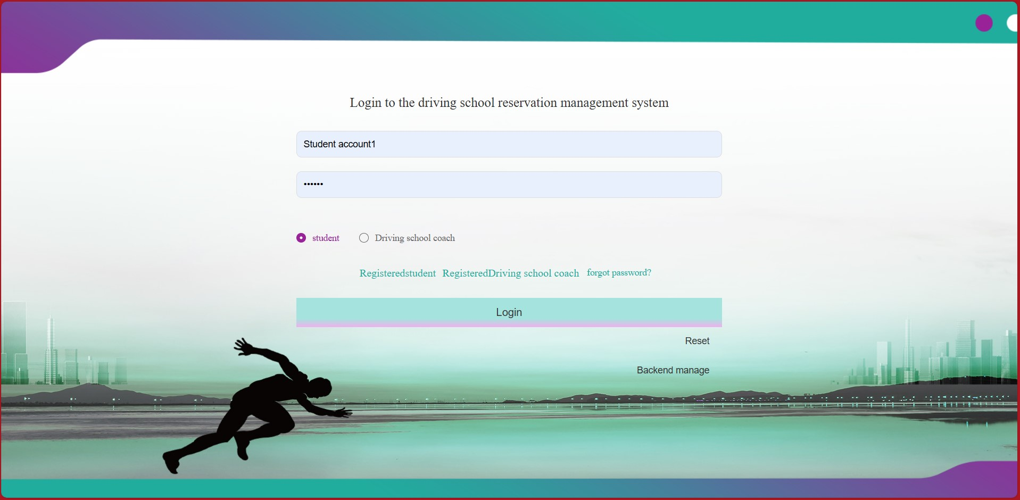

Figure 34. Correct account, password, option login page

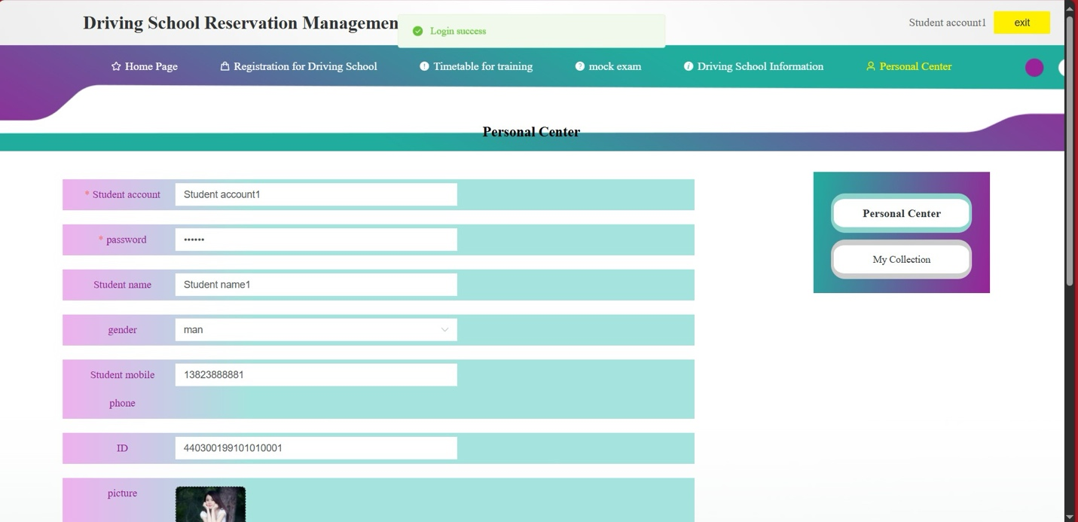

Figure 35. Login succussed

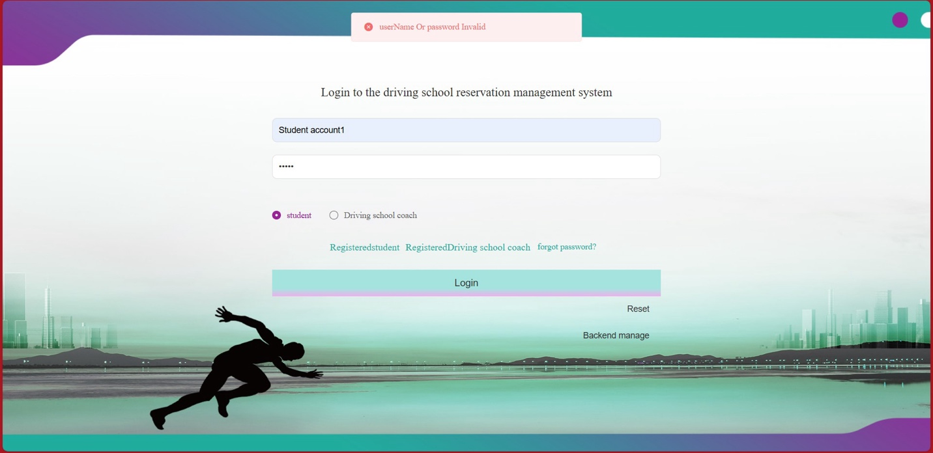

Figure 36. Correct account, wrong password, correct option (Login failed)

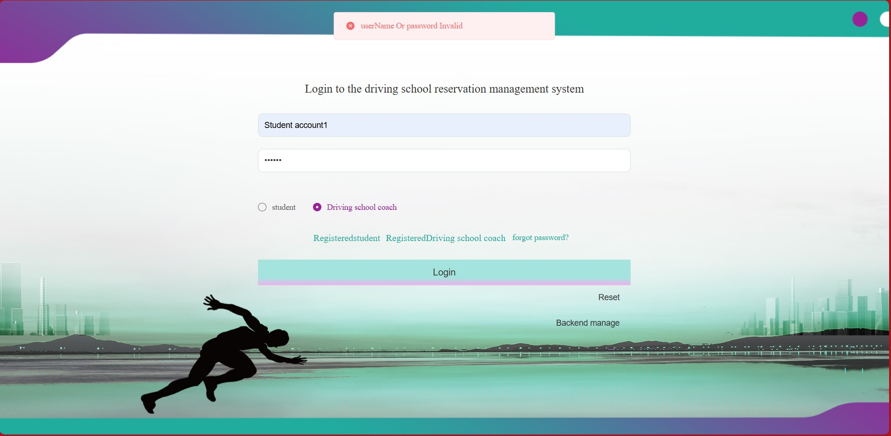

Figure 37. Correct account, password, wrong option (Login failed)

The login function works perfectly and when the inputs were wrong, it will also give out suitable error messages. After tested, all the function that I prepared to test are all tested without problems, all the function can run smoothly. It passed the unit test.

1. **Integration testing**

This test is aiming to test all the roles (Administrator, Student and Coach) doing operations, to verify that all the operations can co-operate together. The use case below shows the verifying process:

|  |  |  |  |  |
| --- | --- | --- | --- | --- |
| Use case ID | Operation description | Test data | Expected result | Test result |
| 1 | Administrator input the account and password, then click the “Login” button. Then, administrator click “Student Management”, then select “info” of the first student. Then delete the first student. | Account: admin  Password: admin  Student’s name: Student account 8  Gender: man  Phone number: 13823888888  ID: 440300199808080008  Security question: security question8  Security question answer: security question 8 | After successfully logged in the system, click the “info” button, all the information of the first student will be shown. After deleted the first student, the information will be removed from the platform. | Same with the expected result |
| 2 | Student input the correct account and password, then click the “Login” button, then click the “Timetable for training” bar, then click select coach, select Coach 1, then select data as “April 16”, then select a class then click the “Submit” button.  Coach input the correct account and password, then click the “Login” button, then click the “Timetable for training” bar, then click select coach, select Coach 1, then select data as “April 16”, then check the timetable. | Account: Student account 1  Password: 123456  Account: Coach account 1  Password: 123456 | Student will successfully be making a practice reservation.  The coach will receive a notification about the new reservation. Then the coach checks the timetable will find out that there’s a reservation indeed. | Same with the expected result |

Table 6. Integration test plan

The test result will be shown below:

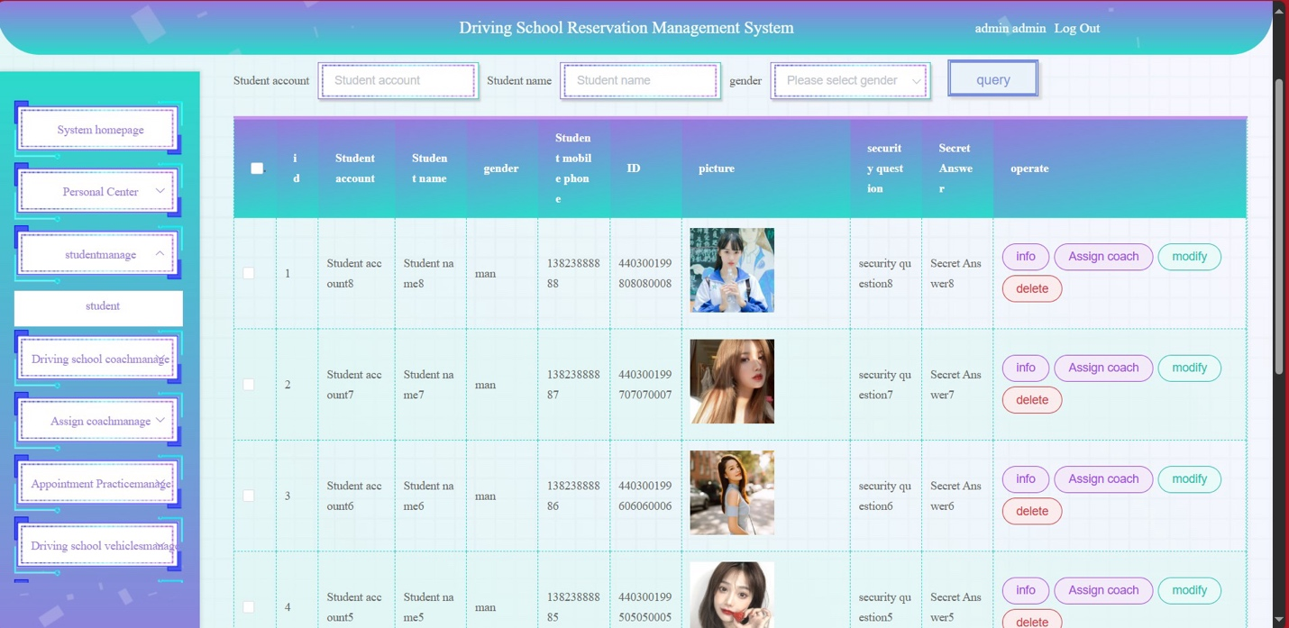

Figure 38. Student information display page

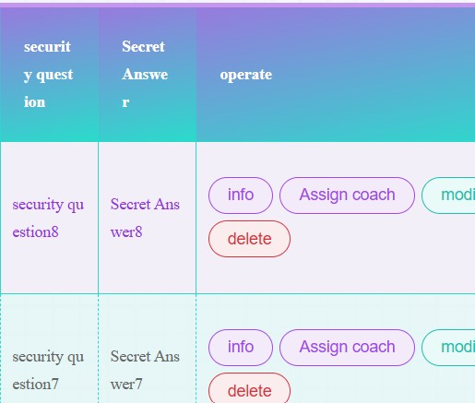

Figure 39. Click "info" button

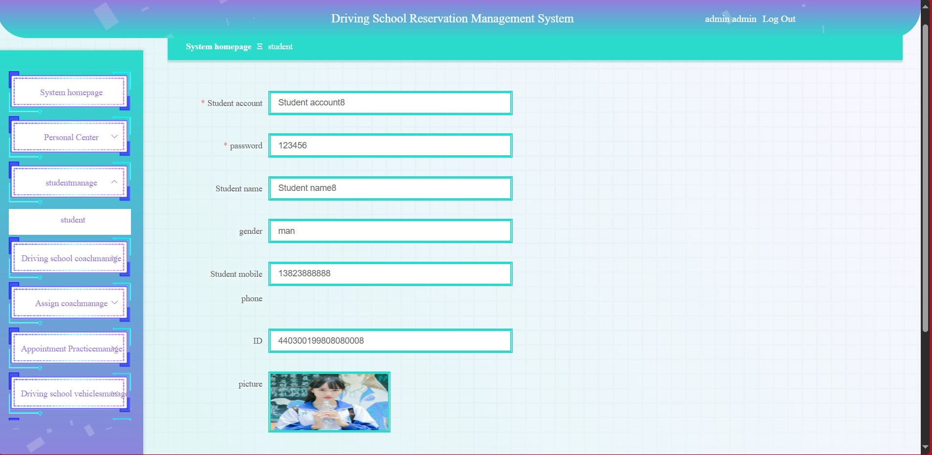

Figure 40. Information details display



Figure 41. Click "delete" button

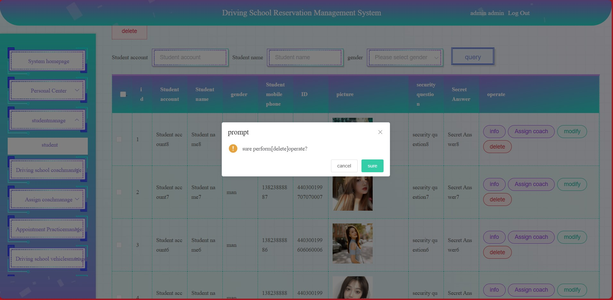

Figure 42. Delete conformation message

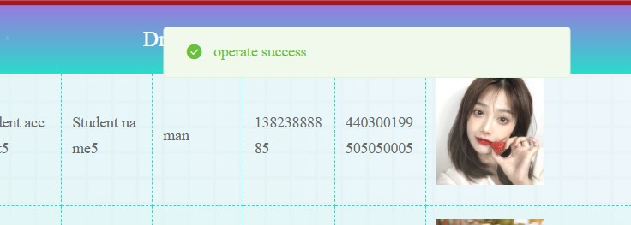

Figure 43. Delete succussed



Figure 44. Student login

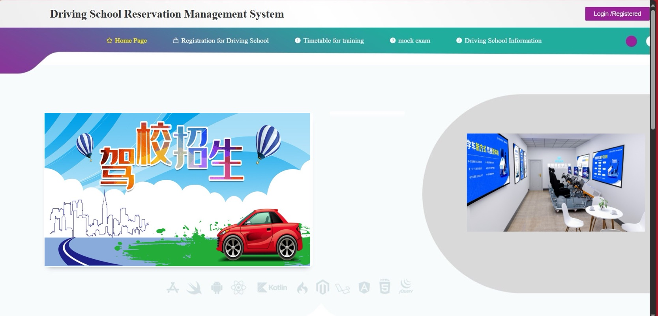

Figure 45. After logged in, homepage

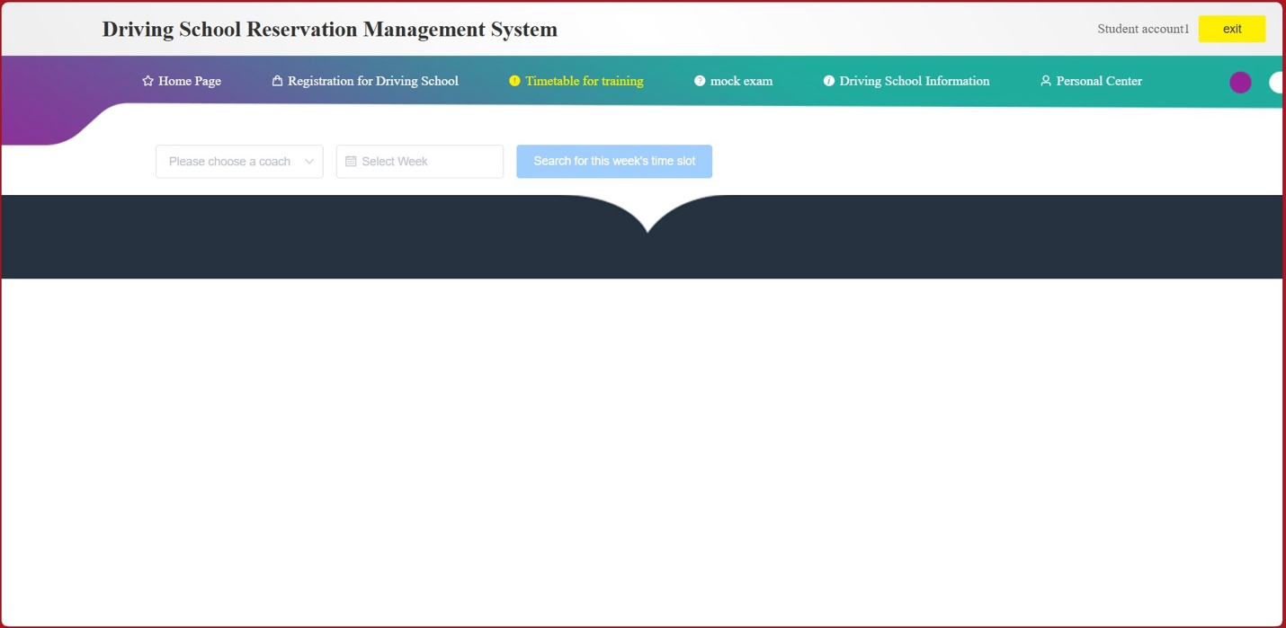

Figure 46. Empty timetable

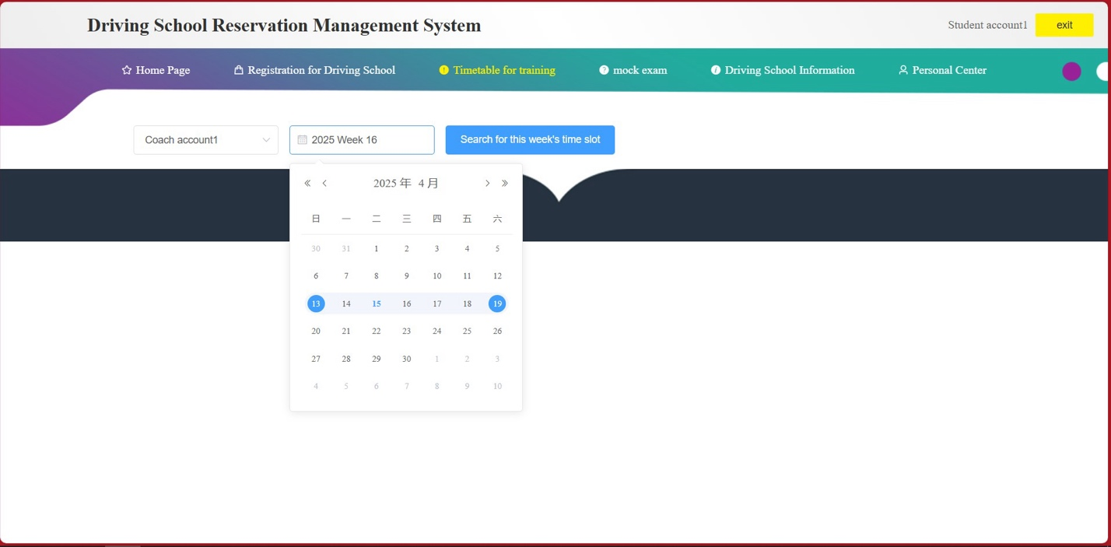

Figure 47. Date selection

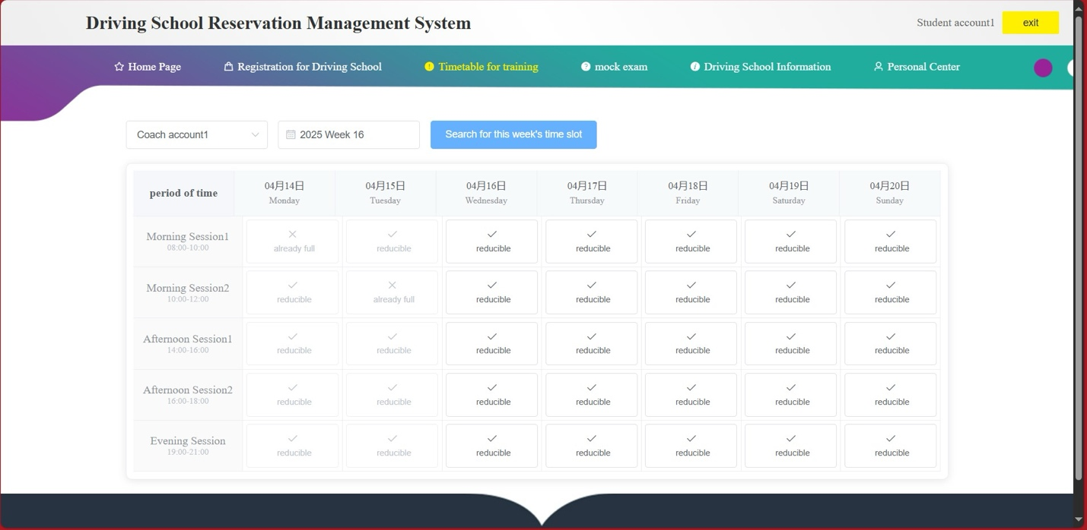

Figure 48. Timetable for that day

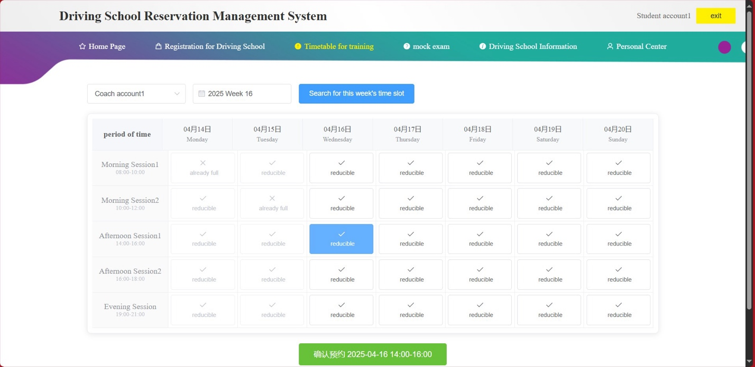

Figure 49. Select a practice day (reservation)

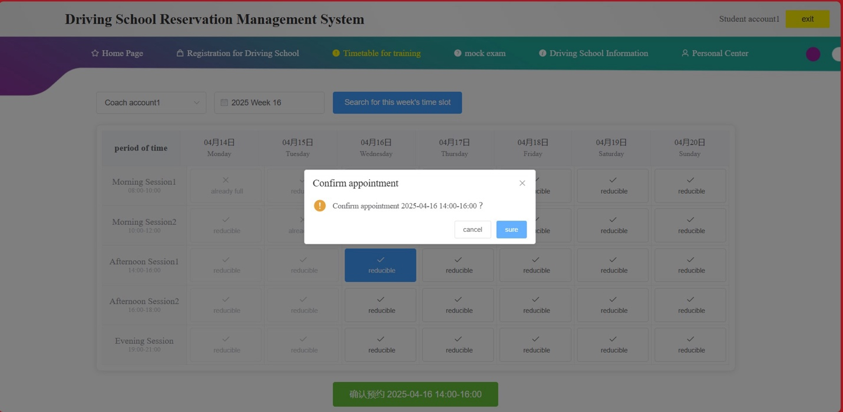

Figure 50. Reservation conformation

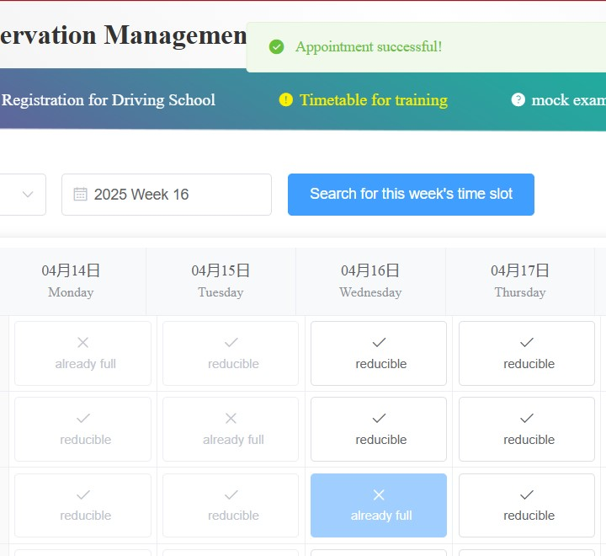

Figure 51. Reserve succussed

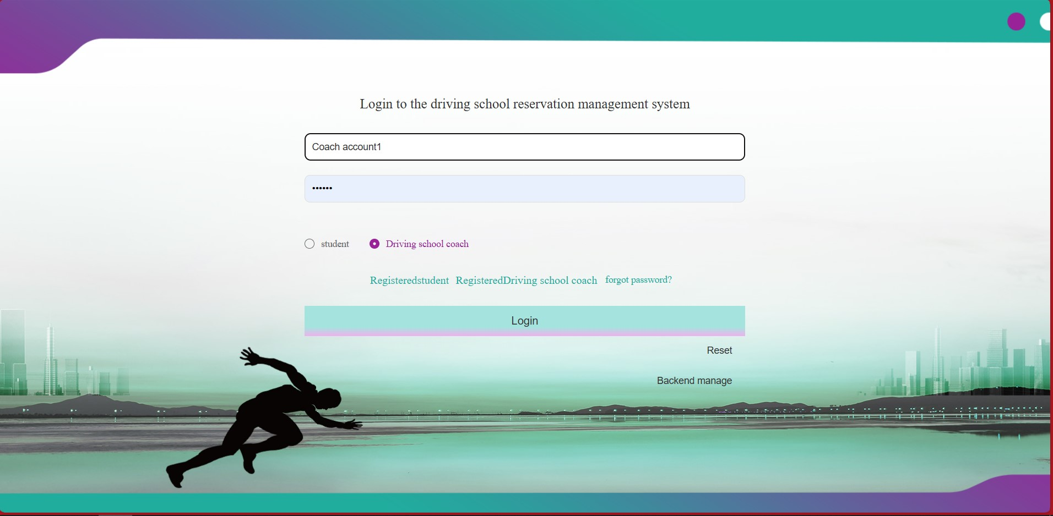

Figure 52. Coach login

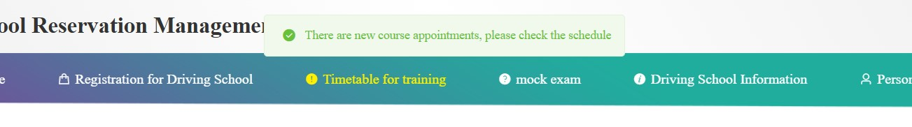

Figure 53. Coach received a new notification

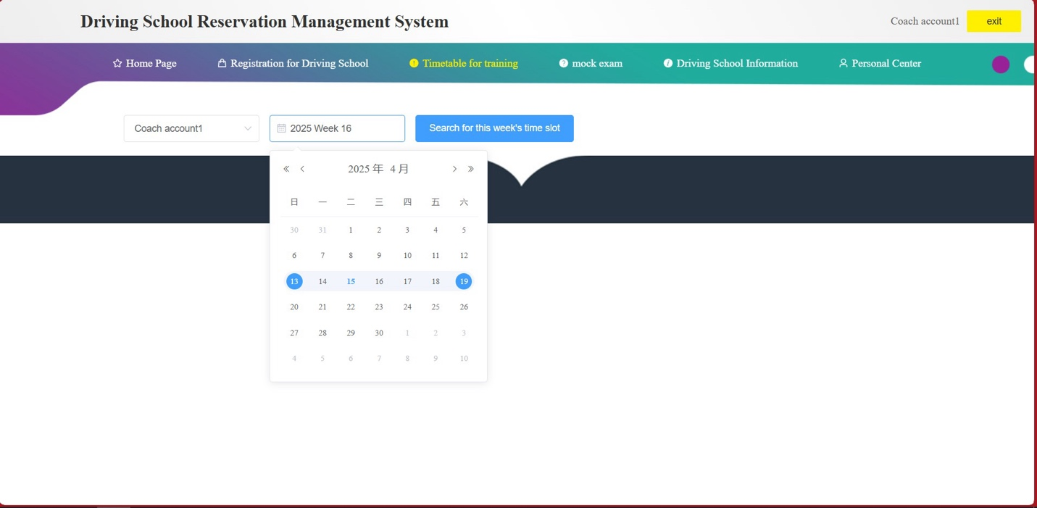

Figure 54. Coach selects the same date

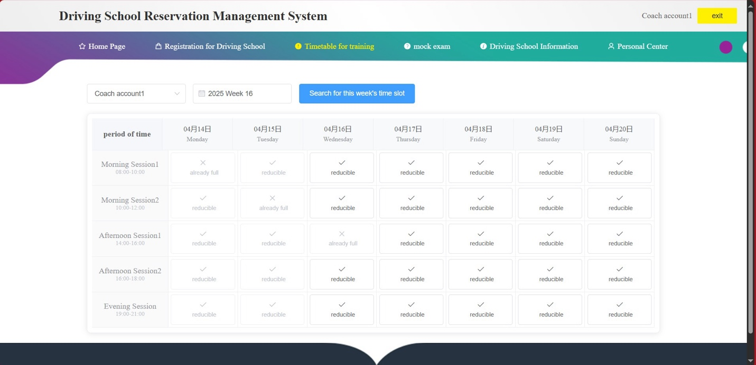

Figure 55. Coach checks the timetable (Reserved)

The administrator can check and delete information at the same time, the student can make practice reservation on the timetable, and the coach can receive a notification and also can see the reservation on timetable.

After doing this test, I found out that all functions of all roles (administrator, student and coach) can be operated at the same time and there will be no error. So, it passed the integration test.

1. System testing

This test is aiming to test the whole system security level, to verify if the system can resist basic security attack, for example, if somebody change the URL in the back-end page URL (no logged in state) when logging in, check if the page will display.

|  |  |  |  |  |
| --- | --- | --- | --- | --- |
| Use case ID | Operation description | Test data | Expected result | Test state |
| 1 | In not logged in state, change the URL to the administrator homepage. | URL: | Unable to access the interface, the login pages is displayed. | Same with the expected result |

Table 7. System test plan

The test process will be shown below:

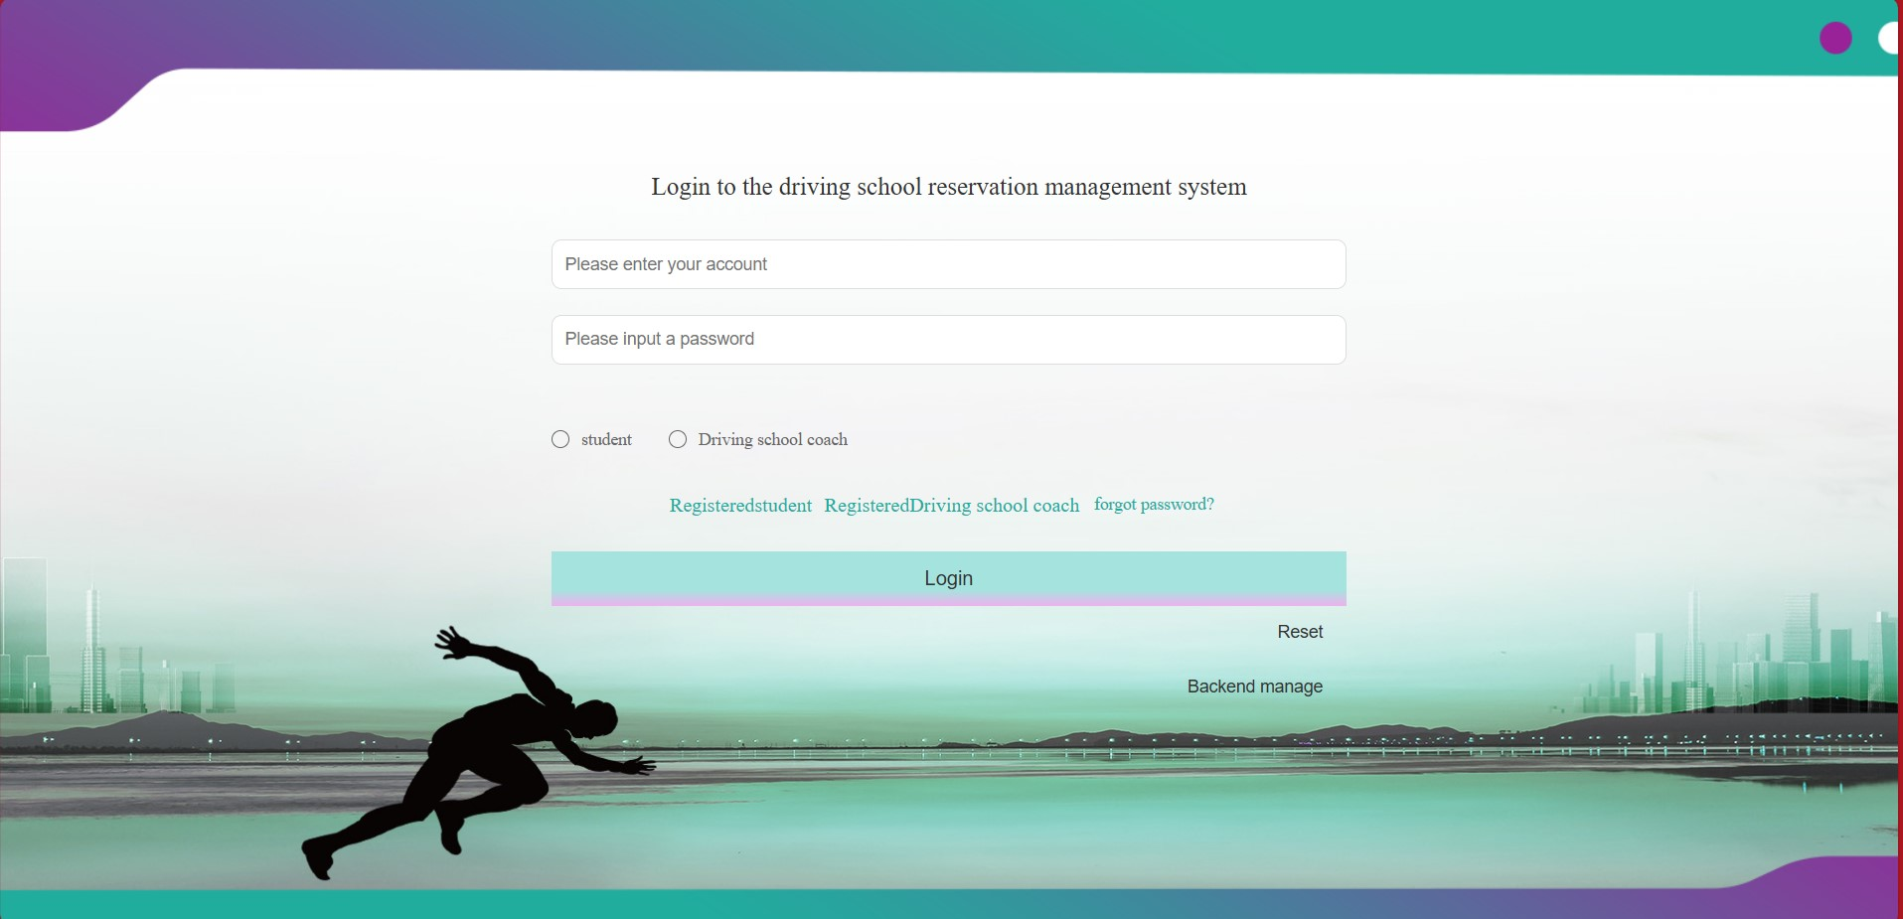

Figure 56. Empty login page

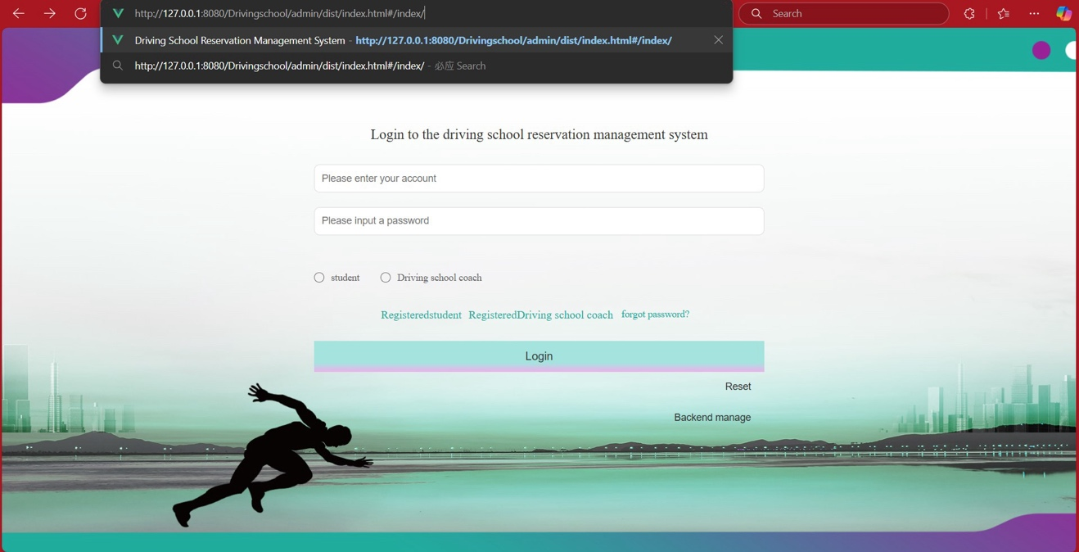

Figure 57. Input back-end platform URL

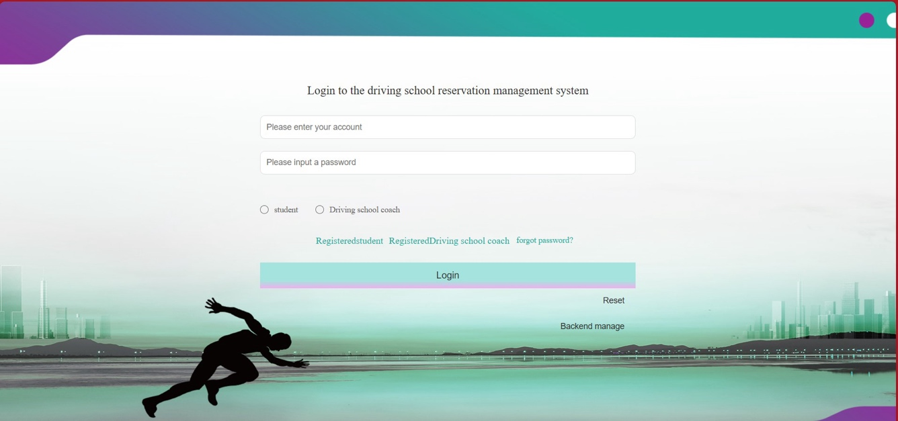

Figure 58. Failed to achieve back-end

So, it’s not possible to change the login page directly into the back-end management platform by only changing URL. And it’s clear that all the password in the database are all encrypted.

This website has the basic security, but basic security is in place on the website. The website's data is secured using encryption methods and kept in a database. The system test's security test succeeded at first, but it has to be enhanced because the website is vulnerable to attacks due to its basic construction.

## **Evaluation and discussion**

This project construct with front-end, back-end and MySQL, which provide the core functions of the driving school management system, make administrator, students and coaches all can perform their own tasks in the system. During the project evaluation, nearly all the basic functions been implemented, as shown in the “4.2 Implementation” section. The admin can check the student’s information, assign the coach and etc. Student can sign up online, make practice reservation and etc. Coach can check the session arrangement, make study plan and etc.

* User interface friendly: This project is designed for users like administrator, student and coach who are not familiar with coding, so the interface, the UI need to be clear and straightforward, need to be user friendly, in case some users don’t know how to use it. The front-end interface is designed well, it’s clean, simple to understand, easy to use. However, the UI still need to improve, it can be more modernize, the visual effect needs to be improved.
* Accessibility: This system distributes different clearance for different roles, like for administrator and student, all the pages have different access permission, which make the system more organized. But the logic of distributing the permission still needs optimization. Such as, the process of coach disturbing and student registration can be more automated and intelligent.
* Security: This project constructs a website, which is easy to get attack. Because for now the database haven’t encrypt all the data which collected from the front-end, so if the database been breached, all the data can be exposed, so the security level is relatively low.

## **Constrains and limitations**

The goal of developing this project is to construct a driving school management system, so the target customer are basically students and coaches in the driving school, so this project cannot be widely used to the public, only internal use in driving school. And this project is developed with Incremental Model, so during the developing process, it has to perform demand analysis, because some of the tasks need to be finish first. To make sure that all the tasks from different stage can be finished in time, it’s usually need to handle difficult and risky tasks first.

# **Professional Issues**

This part is used to look at the project's expertise, risk assessment, and expertise problems and figure out how they all fit together based on the project's completion.

## **Project Management**

This part is where to plan the project, make a thorough plan, set up tasks, and break them down into smaller tasks. Which can also use this section to plan the project's time and data.

### **Activities**

Here is the section where to show the planning of the project. Which includes set up tasks and divide them into small tasks to complete, the process will be shown below:

|  |  |  |
| --- | --- | --- |
| Tasks | Activities (small tasks) | Status |
| Do survey and research on existing driving school management system and gather using experience and data. | Find suitable websites and use them, then collect using experience. | Completed |
| Find suitable support paper or essay and collect data from them. | Completed |
| A real data model for the driving school management system is being made, as well as a database for the classification. | Construct a basic data structure base on the requirement analysis. | Completed |
| Put more detail data structure in to the basic one, find out the interaction model between different data table. | Completed |
| Design and develop a clean, easy to use and good-looking front-end interface, including the design for all the button for all the button, and also design the interfaces for the back-end to use. | Draw a basic format for all the interfaces, including login, homepage and etc. | Completed |
| Begin to write code for all the interfaces. | Completed |
| Make a good back-end with all the functions that the website need and links with the front-end so it can call methods from the front-end to get data and add it to the database or from the database to send data to the front-end. | Connect the front-end and the database together. | Completed |
| Make sure the data from the front-end (login, registration and etc.), can collect by database successfully. | Completed |
| Finish the function of adding, deleting, modifying and searching data. | Completed |
| Make sure that the administrator can have the full access in the back-end platform that no one else can. | Completed |
| Test all the functions by using different data. | Login, registration function | Completed |
| Test functions from the database, functions like adding, deleting, modifying and searching. | Completed |
| Test all the functions from different roles, like student, coach and administrator. | Completed |

Table 8. Project planning

### **Schedule**

This section is about my project develop timetable, using a Gantt chart to plan for each part of develop can directly display the timeline of my project developing, the use of Gantt chart can reduce time use greatly, and simplify the problem.

The Gantt chart will be shown below:

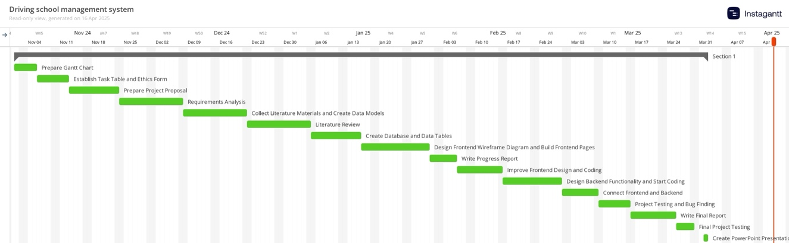

Figure 59. Gantt chart

This chart can display basically the whole process, the whole timeline of my project development, this project had been split into many small tasks, and all the tasks are completed, so the Gantt chart can really help user to have a clear goal and deadline for develop project.

### **Project Data Management**

This section

### **Project Deliverables**

In this section, briefly list all the documents and project resources that have been submitted for assessment. Example: Project proposal, progress report, final report, project code/ software, poster presentation file, etc.

## **Risk Analysis**

Risk analysis as informed by the current project progress; Resolved risks and the success of the mitigation strategy; Changes to the project plan as a result of risks; Future risks.

## **Professional Issues**

Identification and discussion of relevant legal, social, ethical, and environmental issues in the context of the project. Refer to professional codes of conduct, e.g. BCS, ACM.

# **Conclusion**

Summary of what was achieved and potential future work.

# **References**

[1] Bowen, L. et al. (2020) ‘Factors underpinning unsafe driving: A systematic literature review of car drivers’, *Transportation Research Part F: Traffic Psychology and Behavior*, Volume 72, pp. 184-210. Available at: <https://www.sciencedirect.com/science/article/abs/pii/S1369847820304046> (Accessed: 25/10/2024).

[2] LEARNER DRIVER ZONE, (2022) *How to Book A Driving Test.* Available at: <https://learnerdriverzone.co.uk/helpful-guides/booking-a-driving-test/> (Accessed: 25/10/2024).

[3] Martin-delosReyes, L. M. et al. (2019) ‘Efficacy of training with driving simulators in improving safety in young novice or learner drivers: A systematic review’, *Transportation Research Part F: Traffic Psychology and Behavior,* Volume 62, pp. 58-65. Available at: <https://www.sciencedirect.com/science/article/abs/pii/S1369847818304406> (Accessed: 26/10/2024).

[4] Tairova, M. (2020) Getting A Driver’s License In South Korea: Complete Guide. Available at: <https://koreabyme.com/getting-a-drivers-license-in-south-korea-complete-guide/> (Accessed: 26/10/2024).

[5] Zhou, J. et al. (2016) ‘Design and Implementation of Driving School Information Management System Based on Dreamweaver’, International Conference on Sensor Network and Computer Engineering, Volume 6, pp. 510-514. Available at: <https://www.semanticscholar.org/paper/Design-and-Implementation-of-Driving-School-System-Zhou-Cai/add33d6ad4958cb9346824c062b370fe98022478> (Accessed: 26/10/2024).

* The layout above is a suggestion of how to present your Final Project Report. Whenever appropriate, introduce sections that will help the readability of your work.
* The Length of the final report should be **8000 – 10000 words**.
* All sections and subsections should be numbered for cross-referencing purposes.
* Regarding citations and references, students must adhere to the University guidelines or IEEE referencing style. **Students doing software development-based projects can cite related websites, web applications, developer documentation, etc. They can cite related articles to their projects, but it is not required. Students doing research-oriented projects should focus on citing research articles. They can also cite appropriate websites whenever necessary. Students are advised to use appropriate reference management software such as Mendeley Reference Manager or Zotero to ensure the correctness of all references.**

## **Formatting Requirements**

Your written report must be presented in the following format:

* All main sections/chapters should begin on a new page. The Declaration page, Tables of Contents pages, Acknowledgment, Abstract, Abbreviation, Glossary, Project Chapters (Chapters 1 to 6), and Appendices should all start on a new page.
* It must be word-processed in 11-point Arial font.
* It must be black text on a white or ivory background
* All pages must be numbered. Follow the appropriate page numbering format specified in the template.
* Margins must be as follows: Top: 1 inch, Bottom: 1 inch (2.5 cm), Left: 1.25 inches, Right:
* 1.25 inches (3.2 cm)
* Use a line spacing of 1.5
* Numbers and captions to figures and tables should be at the bottom of the figure or table. If the figure or table is mounted sideways into the report, then its bottom is on the right-hand side of the report. **All tables and figures must be labeled**.
* Normally, the report should not contain more than 80 tables/figures.

## **Written Presentation**

* The final project report must have a concise written presentation and referencing style.
* It should also have a clear & logical presentation.

**NOTE:**

1. **All the text in red colour are basic guidelines and must be DELETED after using this guide.**
2. **Finally, update the “Table of Contents” appropriately to display the correct section titles and corresponding page numbers.**

# **Appendices**

This section can have the essential information/data that are necessary to be included within the report but would disrupt the flow of the main argument. This section is not marked. Examples include links to data and software repositories, questionnaires, raw survey results, and wireframes.